



JAVA WEB
/smlcodes /smlcodes /smlcodes

A SmlCodes.Com Small presentation
In Association with Idleposts.com

Satya Kaveti


So called TITLE
JDBC –Servlets –JSP -Struts
Small Codes
Programming Simplified

Copyright © 2016 SmlCodes.com All rights Reserved.

For more tutorials & Articles visit SmlCodes.com

Copyright © 2016 Smlcodes.com
All rights reserved. No part of this book may be reproduced, stored in a retrieval system, or transmitted in any form or by any means, without the prior written permission of the publisher, except in the case of brief quotations embedded in critical articles or reviews.
Every effort has been made in the preparation of this book to ensure the accuracy of the information presented. However, the information contained in this book is sold without warranty, either express or implied. Neither the author, SmlCodes.com, nor its dealers or distributors will be held liable for any damages caused or alleged to be caused directly or indirectly by this book.
Smlcodes.com has endeavored to provide trademark information about all the companies and products mentioned in this book by the appropriate use of capitals. However, SmlCodes.com Publishing cannot guarantee the accuracy of this information.
If you discover any errors on our website or in this tutorial, please notify us at support@smlcodes.com or smlcodes@gmail.com

First published on Aug 2016, Published by SmlCodes.com

Author Credits
Name : Satya Kaveti
Email : satyakaveti@gmail.com
Website : smlcodes.com, satyajohnny.blogspot.com

Digital Partners

Table of Content
Table of Content 3
I. Start Here 4
Change Table Content Top REFERENCES (5th Tab) update content

1. SQL Basics

I.Introduction to SQL
SQL is a standard language for accessing and manipulating databases
RDBMS
- RDBMS stands for Relational Database Management System.
- RDBMS is the basis for SQL, and for all modern database systems such as MS SQL Server, IBM DB2, Oracle, MySQL, and Microsoft Access.
- The data in RDBMS is stored in database objects called tables.
- A table is a collection of related data entries and it consists of columns and rows
1. Database Tables: A database most often contains one or more tables. Each table is identified by a name (e.g. "Customers" or "Orders"). Tables contain records (rows) with data
2. SQL Statements Most of the actions you need to perform on a database are done with SQL statements. SQL keywords are NOT case sensitive: select is the same as SELECT

1.1 SQL Operations
Some of the Most Important SQL Commands
- CREATE DATABASE - creates a new database
CREATE DATABASE `jdbc`

- DROP DATABASE - modifies a database
DROP DATABASE `jdbc`

- CREATE TABLE - creates a new table
CREATE TABLE `student` (
`sno` INT NOT NULL,
`name` VARCHAR(50) NULL,
`address` VARCHAR(50) NULL,
PRIMARY KEY (`sno`)
);

- ALTER TABLE - modifies a table
ALTER TABLE `student` ADD COLUMN `city` INT(11) NOT ;

- DROP TABLE - deletes a table
DROP TABLE `student;

- CREATE INDEX - creates an index (search key)
ALTER TABLE `student` ADD UNIQUE INDEX `city` (`city`);

- DROP INDEX - deletes an index
ALTER TABLE `student` DELETE UNIQUE INDEX `city` (`city`);

- INSERT INTO - inserts new data into a database
INSERT INTO `student` (`name`, `address`) VALUES ('Ravi', 'HYD');

- SELECT - extracts data from a database
- UPDATE - updates data in a database
- DELETE - deletes data from a database

Select Operations
SELECT * FROM `student`;
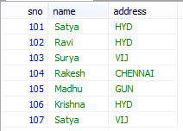
SELECT s.sno, s.name FROM `student` s;
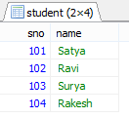
SELECT * FROM `student` s WHERE s.sno =104;
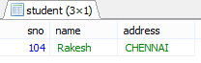
SELECT * FROM `student` s WHERE s.name="Satya" AND s.address="HYD";

SELECT * FROM `student` s WHERE s.name="Satya" OR s.address="HYD";
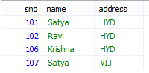

SELECT * FROM `student` s WHERE s.name like '%a';
- like '%a' Ending with ‘a’
- like 'a%' Starting with ‘a’
- like '%a%' Contains with ‘a’
- like '%' Contains any

SELECT * FROM `student` s WHERE s.address IN ('HYD', 'VIJ');
IN operator allows you to apply multiple where conditions
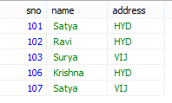

SELECT * FROM `student` s WHERE s.sno BETWEEN 103 AND 106
(Mostly used in date comparision)
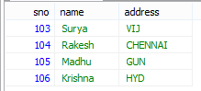

SELECT DISTINCT s.address FROM `student` s;
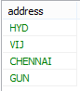
SELECT s.name AS 'Student_Name', s.address AS 'CITY' FROM `student` s
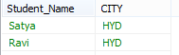

SELECT * FROM `student` s ORDER BY s.address asc; (default)
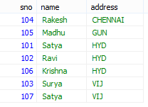
SELECT * FROM `student` s ORDER BY s.address desc;
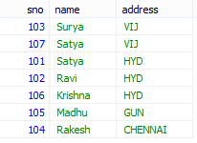
UPDATE student` SET `name`='Vishnu' WHERE `sno`=107 AND `name`='Satya' AND `address`='VIJ' LIMIT 1;

DELETE FROM `mydb`.`student` WHERE `sno`=107 AND `name`='Vishnu' AND `address`='VIJ' LIMIT 1;

1.2 JOINS
An SQL JOIN clause is used to combine rows from two or more tables, based on a common field between them.
Rules
- At least on common column must be present beween two tables
- PRIMARY_KEY of one table as FORIEN_KEY of another table is recommended.

PRIMARY KEY Constraint
- The PRIMARY KEY constraint uniquely identifies each record in a database table.
- Primary keys must contain UNIQUE values.
- A primary key column cannot contain NULL values.
- Table can have only ONE primary key.

FOREIGN KEY Constraint
- A FOREIGN KEY in one table points to a PRIMARY KEY in another table.

CASCADE will propagate the change when the parent changes. (If you delete a row, rows in constrained tables that reference that row will also be deleted, etc.)
SET NULL sets the column value to NULL when a parent row goes away.
RESTRICT causes the attempted DELETE of a parent row to fail.
CREATE TABLE `customer` (
`cid` INT NOT NULL,
`name` VARCHAR(50) NULL,
`addr` VARCHAR(50) NULL,
PRIMARY KEY (`cid`)
) ;

CREATE TABLE `order` (
`ord_id` INT NOT NULL,
`ord_item` VARCHAR(50) NULL,
`ord_date` VARCHAR(50) NULL,
`cid` INT NULL,
PRIMARY KEY (`ord_id`),
CONSTRAINT `FK__customer` FOREIGN KEY (`cid`) REFERENCES `customer` (`cid`) ON UPDATE CASCADE ON DELETE CASCADE
)
COLLATE='utf8_general_ci'
ENGINE=InnoDB;
SELECT `DEFAULT_COLLATION_NAME` FROM `information_schema`.`SCHEMATA` WHERE `SCHEMA_NAME`='mydb';

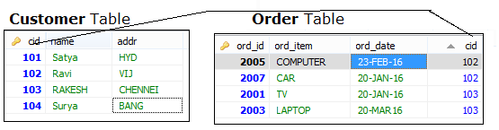
We have 4 types of Joins
- INNER JOIN:
Returns all rows when there is at least one match in BOTH tables
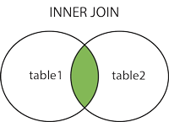
SELECT * FROM customer c INNER JOIN `order` o ON c.cid=o.cid
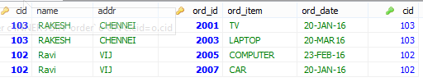

2. LEFT JOIN:
Return all rows from the left table, and the matched rows from the right table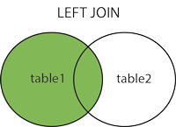
SELECT * FROM customer c LEFT JOIN `order` o ON c.cid=o.cid
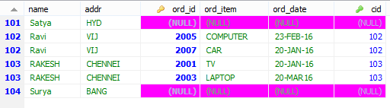

3. RIGHT JOIN:
Return all rows from the right table, and the matched rows from the left table
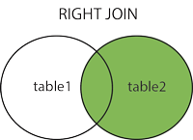
SELECT * FROM customer c RIGHT JOIN `order` o ON c.cid=o.cid
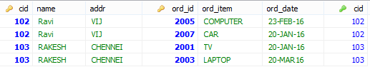

4. FULL JOIN:
Return all rows when there is a match in ONE of the tables
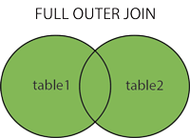
SELECT * FROM customer c FULL OUTER JOIN `order` o ON c.cid=o.cid
In MySQL we don’t have Full Outer Join, for this we have to use Unions
UNION Operator
SQL UNION operator combines the result of two or more SELECT statements
SELECT * FROM customer c WHERE c.cid>102
UNION
SELECT * FROM customer c
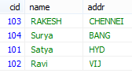
- The UNION operator selects only distinct values by default.
- To allow duplicate values, to get duplicates also use UNION ALL
- Column name must be equal in TWO tables

SELECT INTO
SELECT INTO statement copies data from one table and inserts it into a new table.
SELECT * INTO old_customer FROM customer; (mysql not supporting)

INSERT INTO SELECT
It selects data from one table and inserts it into an existing table

Constraints
- NOT NULL - Indicates that a column cannot store NULL value
- UNIQUE - Ensures that each row for a column must have a unique value
- PRIMARY KEY - A combination of a NOT NULL and UNIQUE
- FOREIGN KEY - Ensure the referential integrity of the data in one table to match values in another table
- CHECK - Ensures that the value in a column meets a specific condition
- DEFAULT - Specifies a default value for a column

Views
View is a virtual table based on the result-set of an SQL statement.
- A view contains rows and columns, just like a real table.
- The fields in a view are fields from one or more real tables in the database

CREATE OR REPLACE VIEW view_name AS
SELECT column_name(s)
FROM table_name
WHERE condition
CREATE OR REPLACE VIEW [Current Product List] AS
SELECT ProductID,ProductName,Category
FROM Products
WHERE Discontinued=No

We can perform INSERT, DELETE, UPDATE Opetations as normal as Table operations
Date Functions
The following table lists the most important built-in date functions in MySQL:
Function | Description
NOW() | Returns the current date and time
CURDATE() | Returns the current date
CURTIME() | Returns the current time
DATE() | Extracts the date part of a date or date/time expression
EXTRACT() | Returns a single part of a date/time
DATE_ADD() | Adds a specified time interval to a date
DATE_SUB() | Subtracts a specified time interval from a date
DATEDIFF() | Returns the number of days between two dates
DATE_FORMAT() | Displays date/time data in different formats

1.3 Sql Functions

Number functions
- AVG() - Returns the average value
- COUNT() - Returns the number of rows
- FIRST() - Returns the first value
- LAST() - Returns the last value
- MAX() - Returns the largest value
- MIN() - Returns the smallest value
- SUM() - Returns the sum

String functions
- UCASE() - Converts a field to upper case
- LCASE() - Converts a field to lower case
- MID() - Extract characters from a text field
- LEN() - Returns the length of a text field
- ROUND() - Rounds a numeric field to the number of decimals specified
- NOW() - Returns the current system date and time
- FORMAT() - Formats how a field is to be displayed

1.4 PL/SQL
PL/SQL stands for (Procedural Language/Structure Query Language). It is extension of SQL

2.1 Bascis
- Datatpye
Below are supported Datatypes in PL/SQL which are supported in SQL.
 | Data type | Syntax
1 | Integer | INTEGER
2 | Smallint | SMALLINT
3 | Numeric | NUMERIC(P,S)
4 | Real | REAL
5 | Decimal | DECIMAL(P,S)
6 | Float | FLOAT(P)
7 | Character | CHAR(X)
8 | Character varying | VARCHAR2(X)
9 | Date | Date
10 | Time | TIME

- Variables
Variable Declaration
Variable_name datatype;
a number;

Variable Initialization
Variable_name datatype:=value;
a number=10;

3. Input Statement : to provide input value at run time by using operator (&).
4. Output Statement:
dbms_output.put_line ('Message' || variable);
dbms_output.put_line ('Sum: ' || c);
Basic Syntax
begin
dbms_output.put_line("Hello word");
end;
Very simple, in the place of { }, we use begin … end;

Procedure
A pl-sql Procedure does not return any value. Procedure has two sections;
- Declaration of the procedure: Declaration of procedure always start with a keyword create ends with last variable parameters.
- Body of the procedure: Body of procedure starts with a keyword called is or as and ends with end statement.
Example
create or replace procedure p1(a in number, b out number, c out number, d out number)
is
begin;
select ename, sal, deptno, into b, c, d from emp where empno=a;
end;

Function
A PL/SQL Function is a self control block which is used to perform some specific task. function must always return a value, but a procedure may or may not return a value.
create or replace function add(a number, b number)
return number
is
number;
begin;
a:=10;
b:=20;
c=a+b;
return c;
end;

Package is a collection of sub-programs that means function or procedure
create package package_name AS
procedure procedure_name(parameter);
end package_name;

Cursors
A Cursors is a temporary work area created in the system memory when a SQL statement is executed. It is a temporary memory which is used to fetch more than one record at a time from existing table.
Implicit cursor cursor is perform by the system internally
Explicit cursor This type of cursor is performed by the user manually or programatically

Steps to perform cursor
Steps | Syntax
Declare the cursor | open cursor_name;
Open the cursor | open cursor_name;
Fetch the record from the cursor | fetch cursor_name into variables;
Close the cursor | close cursor_name;

Declare the cursor
declare
a emp %rowtype;
cursor c is select * from emp where depno=&deptno;
begin
open c;
loop fetch c into a;
if c % found then
dbms_output.put_line(a.empno || ' ' a.ename || ' ' || a.sal);
else
exit;
end if;
end loop;
close c;
end;

Trigger
Trigger is a pl/sql block structure which is fired when a DML statements like Insert, Delete, Update is executed on a database table. A trigger is triggered automatically when an associated DML statement is executed

Purpose of Triggers
Triggers can be written for the following purposes:
- Generating some derived column values automatically
- Enforcing referential integrity
- Event logging and storing information on table access Auditing
- Synchronous replication of tables
- Imposing security authorizations
- To avoid invalid transactions
- To generate the resulting data automatically.
Part of Trigger
A database trigger has 5 parts.
- Trigger timing
- Trigger event or statement
- Trigger level
- Trigger restriction
- Trigger body
CREATE [OR REPLACE ] TRIGGER trigger_name
{BEFORE | AFTER | INSTEAD OF }
{INSERT [OR] | UPDATE [OR] | DELETE}
[OF col_name]
ON table_name
[REFERENCING OLD AS o NEW AS n]
[FOR EACH ROW]
WHEN (condition)
BEGIN
--- sql statements
END;

Write a trigger to stop delete operation on emp_table
create or replace trigger mytrigger
before
delete
on emp
begin
raise_application_error(-20000, 'sorry we can not delete any record from this table');
end;

References
- http://www.w3schools.com/sql/
- http://www.sitesbay.com/plsql/

2. JDBC

2.1 Introduction
Before JDBC, ODBC API was the database API to connect and execute query with the database. But, ODBC API uses ODBC driver which is written in C language (i.e. platform dependent and unsecured).
That is why Java has defined its own API (JDBC API) that uses JDBC drivers (writtn in Java). 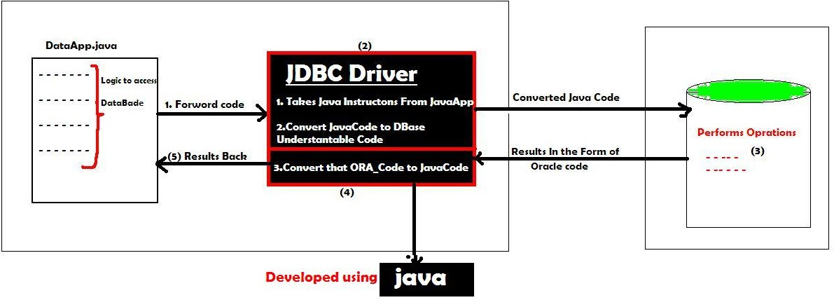
There are 4 types of JDBC drivers:
- JDBC-ODBC bridge driver
- Native-API driver (partially java driver)
- Network Protocol driver (fully java driver)
- Thin driver (fully java driver)

1. JDBC-ODBC bridge driver (Type-1)
- The JDBC-ODBC bridge driver uses ODBC driver to connect to the database.
- The JDBC-ODBC bridge driver converts JDBC method calls into the ODBC function calls.
- Can be easily connected to ANY database.
- Performance degraded because JDBC method call is converted into the ODBC calls
- ODBC driver needs to be installed on the client machine
- Sun provided ODBC driver name : sun.jdbc.odbc.JdbcOdbcDriver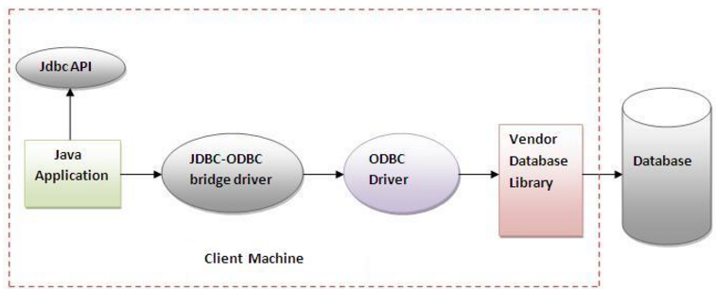
2. Native API driver (Type-1)
- The Native API driver uses the client-side libraries of the database.
- For MySQL they have own Native API Driver, similarly for ORACLE, Postgres etc,
- The driver converts JDBC (Java) method calls into native calls (MySQL, Oracle) of the database API.
- It is NOT FULLY written entirely in java
- The Native driver needs to be installed on the each client machine.
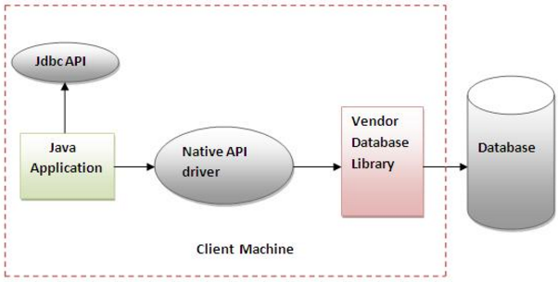

3. Network Protocol driver (Type-3)
- The Network Protocol driver uses middleware (application server) that converts JDBC calls directly or indirectly into the vendor-specific database protocol.
- It is fully written in java.
- Used in Connection Pooling
- Network support is required on client machine.
- Maintenance of Network Protocol driver becomes costly because it requires database-specific coding to be done in the middle tier.
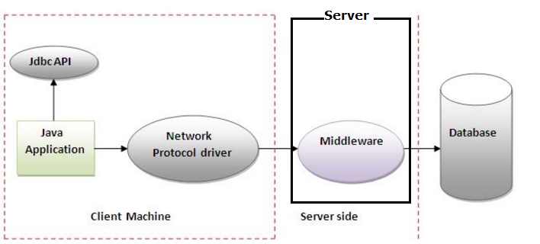
4. Thin driver (Type -4)
- The thin driver converts JDBC calls directly into the vendor-specific database protocol.
- It is fully written in Java language
- Better performance than all other drivers.
- No software is required at client side or server side.
- com.mysql.jdbc.Driver (MySQL), oracle.jdbc.driver.OracleDriver(ORACLE)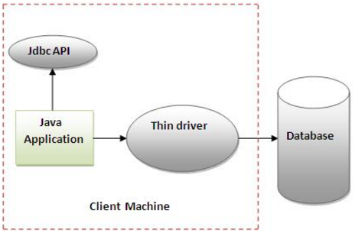

Steps to connect to the database
There are 5 steps to connect...
- Register the driver class
Class.forName ("oracle.jdbc.driver.OracleDriver");

- Creating connection
Connection con=DriverManager.getConnection ("url","system","password");
Connection con=DriverManager.getConnection ("url "); //2nd Way

- Creating statement
Statement stmt=con.createStatement ();

- Executing queries
ResultSet rs=stmt.executeQuery("select * from emp");

- Closing connection
con.close();
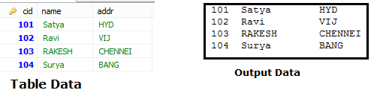
public class JDBC {
public static void main(String[] args) throws Exception {
Class.forName("com.mysql.jdbc.Driver");
Connection con = DriverManager.getConnection
("jdbc:mysql://localhost:3306/mydb", "root", "123456");

Statement stmt = con.createStatement();
ResultSet rs = stmt.executeQuery("SELECT * FROM customer");
while (rs.next())
System.out.println(rs.getInt(1)+":"+rs.getString(2)+ " " + rs.getString(3));
con.close();
}
}
In above Example we use getConnection(“URL”,”UNAME”,”PWD”) to connect with database.we can use directly without giving username/pwd also

There are two ways to connect java application with the access database.
- Without DSN (Data Source Name) above
- With DSN jdbc:odbc:mydsn (mydsn is DSN)
Creating DSN
Start > Administrative Tools > Data Sources (ODBC). Add (.mdb)

2.2 DriverManager class
- The DriverManager class acts as an interface between user and drivers
- It keeps track of the drivers that are available and handles establishing a connection between a database and the appropriate driver.
- The DriverManager class maintains a list of Driver classes that have registered themselves by calling the method DriverManager.registerDriver().
Methods
- public static void registerDriver(Driver driver):
- public static void deregisterDriver(Driver driver):
- public static Connection getConnection(String url):
- public static Connection getConnection(String url,String uname,String pwd)

2.3 Connection interface
A Connection is the session between java application and database. The Connection interface is a factory of Statement, PreparedStatement, and DatabaseMetaData i.e.

- Statement createStatement()
- PreparedStatement prepareStatement(String sql)
- CallableStatement prepareCall(String sql)
- Blob createBlob()
- Clob createClob()
- String getSchema()
- DatabaseMetaData getMetaData()

- void close()
- void commit()
- void rollback()
- void setAutoCommit(boolean autoCommit)
- boolean getAutoCommit()
All above statement related methods can have
- ResultSet.TYPE_SCROLL_SENSITIVE used to move ResultSet Both Directions
- ResultSet.CONCUR_UPDATABLE used to perform DML operations on ResultSet

2.4 Statement interface
- The Statement interface provides methods to execute queries with the database.
- The statement interface is a factory of ResultSet
- it provides factory method to get the object of ResultSet

- public ResultSet executeQuery(String sql):
Is used to execute SELECT query. It returns the object of ResultSet.
- public int executeUpdate(String sql):
Is used to execute DML, CREATE, DROP, INSERT, UPDATE, DELETE etc.
- public boolean execute(String sql):
Is used to execute queries that may return multiple results. >1 if success, 0 on fail
- public int[] executeBatch():
Is used to execute batch of commands.

2.5 ResultSet interface
- The object of ResultSet maintains a cursor pointing to a row of a table.
- Initially, cursor points to before the first row.
- By default, ResultSet object can be moved forward only and it is not updatable.
    - public XXX getXXX(int rowIndex):
    - public XXX getXXX(String rowName):
    - public boolean next()
    - public boolean previous()
    - public boolean first()
    - public boolean last()
executeQuery (String sql) example
We use this method to execute SELECT queries
public class JDBC {
public static void main(String[] args) throws Exception {
Class.forName("com.mysql.jdbc.Driver");
Connection con = DriverManager.getConnection
("jdbc:mysql://localhost:3306/mydb", "root", "123456");

Statement stmt = con.createStatement();
ResultSet rs = stmt.executeQuery("SELECT * FROM customer");
while (rs.next()) {
System.out.println(rs.getInt(1)+""+rs.getString(2)+" "+ rs.getString(3));
}
con.close();
}
}
101 Satya HYD
102 Ravi VIJ
103 RAKESH CHENNEI
104 Surya BANG

executeUpdate (String sql) example
We use this method to NON-SELECT Queries like UPDATE, DELETE, etc
Returns 1 if success
Returns 0 if Failure
public class JDBC {
public static void main(String[] args) throws Exception {
String url = "jdbc:mysql://localhost:3306/mydb";
Class.forName("com.mysql.jdbc.Driver");
Connection con = DriverManager.getConnection(url, "root", "123456");
Statement stmt = con.createStatement();

String qry = "UPDATE `customer` SET `name`='Ram' WHERE `cid`=102";
int res = stmt.executeUpdate(qry);
if (res > 0)
System.out.println("Success is :" + res);
else
System.out.println("Failure is :" + res);
con.close();
}
}
Success is :1
Failure is :0

Boolean execute example
We can use execute() method in both SELECT & NON-SELECT queries.
1. SELECT
It returns TRUE on SELECT queres we can get ResultSet by calling below method
ResultSet rs = statement.getResultSet ()

2. NON-SELECT
It returns FALSE on NON-SELECT queres. we can get Int value by calling below method
int i = statement.getUpdateCount();

public class JDBC {
public static void main(String[] args) throws Exception {
String url = "jdbc:mysql://localhost:3306/mydb";
Class.forName("com.mysql.jdbc.Driver");
Connection con = DriverManager.getConnection(url, "root", "123456");
Statement stmt = con.createStatement();

// String qry = "SELECT * FROM customer";
String qry = "UPDATE `customer` SET `name`='Ram' WHERE `cid`=102";

boolean flag = stmt.execute(qry);
if (flag == true) {
System.out.println("SELECT QUERY\n --------");
ResultSet rs = stmt.getResultSet();
while (rs.next()) {
System.out.println(rs.getString(1) + ":" + rs.getString(2));
}
}
else {
System.out.println("NON-SELECT QUERY\n --------");
int i = stmt.getUpdateCount();
System.out.println("Result is : " + i);
}
}
}
SELECT QUERY
--------
101:Satya
102:Ram
103:RAKESH
104:Surya

NON-SELECT QUERY
--------
Result is : 1

executeBatch(String sql) example
public class BatchDemo {
public static void main(String[] args) throws Exception {

String url = "jdbc:mysql://localhost:3306/mydb";
Class.forName("com.mysql.jdbc.Driver");
Connection con = DriverManager.getConnection(url, "root", "123456");

Statement st = con.createStatement();
st.addBatch("insert into student values(81, 'Syam', 'mtm')");
st.addBatch("insert into student values(11, 'ram', 'mum')");
st.addBatch("insert into student values(14, 'bam', 'kuk')");
st.addBatch("insert into student values(44, 'pram', 'secu')");

int rs[] = st.executeBatch();
int sum = 0;
for (int i = 0; i < rs.length; i++) {
sum = sum + i;
}
System.out.println(sum + "Record are UPDATED using BATCH");
}
}

Scrollabe Resultset(String sql) example
By Default ResultSet Object is not SCROLLABLE & NOT UPDATABLE.to make ResultSet Object to move both Directions we need to configure TYPE & MODE Values
Possible TYPE Values
- ResultSet.TYPE_SCROLL_SENSITIVE (Update Possible)
- ResultSet.TYPE_SCROLL_INSENSITIVE (Default)
Possible MODE Values
- ResultSet.CONCUR_READ_ONLY (Update Possible)
- ResultSet.CONCUR_UPDATABLE (Default)

Methods applicable on Scrolable ResultSet Object
- int getRow() Returns ROW INDEX
- boolean first() Keep CURSOR at 1st Record
- boolean last() Keep CURSOR at LAST Record
- boolean next() Moves Cursor to Forward
- boolean previous() Moves Cursor to Backword
- boolean absolute(int +/-) Moves Cursor to given Index on ResultSet
- boolean relative(int +/-) Moves Cursor to given Index, based on current Row

public class JDBC {
public static void main(String[] args) throws Exception {
String url = "jdbc:mysql://localhost:3306/mydb";
Class.forName("com.mysql.jdbc.Driver");
Connection con = DriverManager.getConnection(url, "root", "123456"); Statement st = con.createStatement
(ResultSet.TYPE_SCROLL_SENSITIVE, ResultSet.CONCUR_READ_ONLY);

ResultSet rs = st.executeQuery("select * from customer");
System.out.println("From Using Next\n------");

while (rs.next()) {
System.out.println(rs.getString(1)+":"+rs.getString(2));
}

System.out.println("\nFrom Using Previous ");
while (rs.previous()) {
System.out.println(rs.getString(1)+":"+rs.getString(2));
}

System.out.println("randomly................... ");

rs.first();
System.out.println(rs.getRow()+"First:"+rs.getString(1)+":"+rs.getString(2));

rs.last();
System.out.println(rs.getRow()+"Last: "+rs.getString(1)+":"+rs.getString(2));

rs.absolute(4);//from starting point to 4 records
System.out.println(rs.getRow()+"Absolute:"+rs.getString(1)+":"+rs.getString(2));

rs.relative(-2); //from here to 2 points back
System.out.println(rs.getRow()+"relative:"+rs.getString(1)+":"+rs.getString(2));
}
}
From Using Next
------
101:Satya
102:Ram
103:RAKESH
104:Surya

From Using Previous
104:Surya
103:RAKESH
102:Ram
101:Satya
randomly...................
1First: 101:Satya
4Last: 104:Surya
4Absolute Record : 104:Surya
2relative Record : 102:Ram

In above example we used on for SCROLLING resultset on both ditections using ResultSet.TYPE_SCROLL_SENSITIVE, ResultSet.CONCUR_READ_ONLY.
If we want perform UPDATE operations & SCROLLING also, we have to use ResultSet.TYPE_SCROLL_SENSITIVE, ResultSet.CONCUR_UPDATABLE
Steps to Perform Insert/ UPDATE /Delete Operations on ResultSet
1. Select the Records
while (rs.next())
{
System.out.println(rs.getRow()+””+rs.getString(1)+","+ rs.getString(2));
}

2. Perform INSERT Operation
System.out.println("1.INSERT OPERATION\n-----");
rs.moveToInsertRow(); // creates Empty Record
rs.updateInt(1, 200);
rs.updateString(2, "SACHIN");
rs.updateString(3, "MUMBAI");
rs.insertRow(); // Inserts Row

3. Perform UPDATE Operation
System.out.println("\n2.UPDATE OPERATION\n-----");
rs.absolute(2); // move to row to update
rs.updateString(3, "KOLKATA");
rs.updateRow();

4. Perform DELETE Operation
System.out.println("\n3.DELTE OPERATION\n-----");
rs.absolute(1); // move to row to DELETE
rs.deleteRow();
Example
public class JDBC {
public static void main(String[] args) throws Exception {
String url = "jdbc:mysql://localhost:3306/mydb";
Class.forName("com.mysql.jdbc.Driver");
Connection con = DriverManager.getConnection(url, "root", "123456");
Statement st = con.createStatement
ResultSet.TYPE_SCROLL_SENSITIVE, ResultSet.CONCUR_UPDATABLE);
ResultSet rs = st.executeQuery("select * from customer");

while (rs.next()) {
System.out.println(rs.getRow() + "->" + rs.getString(1) + "," + rs.getString(2));
}

System.out.println("1.INSERT OPERATION\n-----");
rs.moveToInsertRow(); // creates Empty Record
rs.updateInt(1, 200);
rs.updateString(2, "SACHIN");
rs.updateString(3, "MUMBAI");
rs.insertRow(); // Inserts Row

System.out.println("\n2.UPDATE OPERATION\n-----");
rs.absolute(2); // move to row to update
rs.updateString(3, "KOLKATA");
rs.updateRow();

System.out.println("\n3.DELTE OPERATION\n-----");
rs.absolute(1); // move to row to DELETE
rs.deleteRow();
}
}
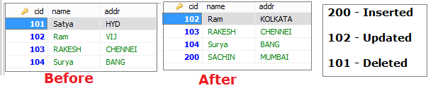

2.6 PreparedStatement
The PreparedStatement interface is a sub interface of Statement. It is used to execute parameterized query.The performance of the application will be faster if you use PreparedStatement interface because query is compiled only once.
String sql="insert into emp values(?,?,?)";
(?) values will be set by calling the setter methods of PreparedStatement.

Method | Description
public void setInt(int index,int value) | sets integer value to the given parameter index.
public void setString(int index, String val) | sets String value to the given parameter index.
public void setFloat(int index, float value) | sets float value to the given parameter index.
public void setDouble(int index, double val) | sets double value to the given parameter index.
public int executeUpdate() | Uses for create, drop, insert, update, delete queries
public ResultSet executeQuery() | Executes the select query.
Boolean execute() | It returns TRUE for SELECT queries, FALSE for update, delete Queries
void addBatch()
ParameterMetaData getParameterMetaData() | Retrieves the number, types and properties of this PreparedStatement object's parameters
ResultSetMetaData getMetaData() | contains information about the columns of the ResultSet object
void setBlob(int index, Blob x)  void setBlob(int index,InputStream is)  void setBinaryStream(int i,InputStream is)  getBinarayStream(“column”); | Inserts Binary Large Object Videos,Audios
void setClob(int index, Clob x)  void setClob(int index, Reader reader)  getCharacterStream(“column”); | Inserts character Large Object Files

java.sql.Statement | java.sql.PreparedStatement
Statement is used for executing a static SQL statement in java JDBC. | PreparedStatement is used for executing a precompiled SQL statement in java JDBC.
java.sql.Statement cannot accept parameters at runtime in java JDBC. | java.sql.PreparedStatement can be executed repeatedly, it can accept different parameters at runtime in java JDBC.
java.sql.Statement is slower as compared to PreparedStatement in java JDBC. | java.sql.PreparedStatement is faster because it is used for executing precompiled SQL statement in java JDBC.

public class JDBC {
public static void main(String[] args) throws Exception {
String url = "jdbc:mysql://localhost:3306/mydb";
String u = "root";
String p = "123456";
PreparedStatement ps=null;
Class.forName("com.mysql.jdbc.Driver");
Connection con = DriverManager.getConnection(url, u, p);

ps = con.prepareStatement("insert into customer values(?,?,?)");
ps.setInt(1, 143);
ps.setString(2, "sri");
ps.setString(3, "mum");
int res = ps.executeUpdate();
System.out.println("Result : " + res);

ps =con.prepareStatement("SELECT * FROM customer c WHERE c.cid<? ");
ps.setInt(1, 200);
ResultSet rs = ps.executeQuery();
while (rs.next()) {
System.out.println(rs.getString(2));
}
}
}
Result : 1
Ram
RAKESH
Surya
sri

2.7 BLOB (BinaryLarge Obejects)
We use BLOB objects to store binary data like images, videos etc
We have following methods to Save & Retrive BLOB Objects
To Save
- void setBinaryStream(int parameterIndex, InputStream x)
- void setBinaryStream(int parameterIndex, InputStream x, int length)
- void setBlob(int index, Blob x)
- void setBlob(int index,InputStream is)
To Retrive
- Blob getBlob(int columnIndex)
- Blob getBlob(String columnLabel)
- InputStream getBinaryStream(int columnIndex)
- InputStream getBinaryStream(String column)

Steps:
- Read Image/ video data by using InputStream
FileInputStream fis=new FileInputStream("d:\\g.jpg");

- Create PreparedStatement Object to write insert image query
PreparedStatement ps=con.prepareStatement("insert into imgtable values(?,?)");

- Set parameter values
ps.setInt(1, 101);
ps.setBinaryStream(2,fis);

- Execute Query
int i=ps.executeUpdate();

- To get image from table execute Select Quey , call on rs object
FileInputSteam fs= rs.getBinarayStream(“column”);

- Choose Location to Store new Image
FileOutputStream fos = new FileOutputStream("res/newpict.gif");



Example BlobInsert Operation
public class BlobInsert {
public static void main(String[] args) throws Exception {
String url = "jdbc:mysql://localhost:3306/mydb";
String u = "root";
String p = "123456";
Class.forName("com.mysql.jdbc.Driver");
Connection con = DriverManager.getConnection(url, u, p);
PreparedStatement ps = con.prepareStatement("insert into blobtest values(?,?,?)");

File f = new File("res/img.gif");
FileInputStream fis = new FileInputStream(f);

ps.setInt(1, 100);
ps.setString(2, "johny");
ps.setBinaryStream(3, fis, (int) f.length());
ps.executeUpdate();
System.out.println("Record is Inserted");
}
}

Example BlobInsert Operation
public class BlobRetrive {
public static void main(String[] args) throws Exception {
String url = "jdbc:mysql://localhost:3306/mydb";
String u = "root";
String p = "123456";
Class.forName("com.mysql.jdbc.Driver");
Connection con = DriverManager.getConnection(url, u, p);
Statement st = con.createStatement();
ResultSet rs = st.executeQuery("select * from blobtest");

if (rs.next()) {
InputStream in = rs.getBinaryStream("img");
FileOutputStream fos = new FileOutputStream("res/newpict.gif");

int bytesRead = 0;
byte[] buffer = new byte[4096];
while ((bytesRead = in.read(buffer)) != -1) {
fos.write(buffer, 0, bytesRead);
}
System.out.println("photo is stored in newpict.gif");
fos.close();
in.close();
rs.close();
st.close();
con.close();
} // if
}// main
}// class

2.8 CLOB
We use CLOB objects to store character data like txt files,word files etc
We have following methods to Save & Retrive CLOB Objects
To Save
- void setCharacterStream(int parameterIndex, InputStream x)
- void setCharacterStream(int parameterIndex, InputStream x, int length)
- void setClob(int index, Clob x)
- void setClob(int index,InputStream is)
To Retrive
- Blob getClob(int columnIndex)
- Blob getClob(String columnLabel)
- InputStream getCharacterStream (int columnIndex)
- InputStream getCharacterStream (String column)

Steps:
- Read File data by using InputStream
FileInputStream fis=new FileInputStream("d:\\g.jpg");

- Create PreparedStatement Object to write insert image query
PreparedStatement ps=con.prepareStatement("insert into filetable values(?,?)");

- Set parameter values
ps.setInt(1, 101);
ps.setCharacterStream (2,fis);

- Execute Query
int i=ps.executeUpdate();

- To get image from table execute Select Quey , call on rs object
FileInputSteam fs= rs. getCharacterStream (“column”);

2.9 CallableStatement
CallableStatement interface is used to call the stored procedures and functions.
We can have business logic on the database by the use of stored procedures and functions that will make the performance better because these are precompiled.
Suppose you need the get the age of the employee based on the date of birth, you may create a function that receives date as the input and returns age of the employee as the output.
Stored Procedure | Function
is used to perform business logic. | is used to perform calculation.
must not have the return type. | must have the return type.
may return 0 or more values. | may return only one values.
We can call functions from the procedure. | Procedure cannot be called from function.
It supports input and output parameters. | Function supports only input parameter.
Exception handling using try/catch block can be used in stored procedures. | Exception handling using try/catch can't be used in user defined functions.

We use following method on Connection object to get CallableStatement Object
public CallableStatement prepareCall("{ call procedurename(?,?...?)}");
CallableStatement cs=con.prepareCall("{call myprocedure(?,?)}");

Example procedeure
create or replace function sum (n1 in number,n2 in number)
return number
is
temp number(8);
begin
temp :=n1+n2;
return temp;
end;
/

In above example n1, n2 are Input Paramaters & temp is the Output parameter
To set Input Paramaters we use setXXX(int index, Value) methods
cs.setInt(1, 10);
cs.setInt(2, 20);

To set Output Paramaters we use registerOutParameter(int index, Type.TYPE) method
cs.registerOutParameter(1, Types.INTEGER);
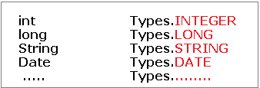
To excute CallableStatement we use execute() method
cs.execute();

To Get results we use getXXX(int outputParamIndex) method
cs.getInt(1);

public class FuncSum {
public static void main(String[] args) throws Exception{

Class.forName("oracle.jdbc.driver.OracleDriver");
Connection con=DriverManager.getConnection(
"jdbc:oracle:thin:@localhost:1521:xe","system","oracle");

CallableStatement stmt=con.prepareCall("{?= call sum4(?,?)}");
stmt.setInt(2,10);
stmt.setInt(3,43);
stmt.registerOutParameter(1,Types.INTEGER);
stmt.execute();

System.out.println(stmt.getInt(1));

}
}
Output: 53

2.10 Metadata
We have 3 types of metadata in jdbc
- DataBaseMetaData
- ResultSetMetaData
- ParameterMetaData

1. DataBaseMetaData
We can get database meta like database details, driver name, name of total number of tables, no.of views etc. by using DataBaseMetaData class, we can get by using Connection Object
DatabaseMetaData getMetaData()
DatabaseMetaData dm = con.getMeteData()

- String getDriverName()
- String getDriverVersion()
- String getURL()
- String getUserName()
- String getDatabaseProductName()
- String getDatabaseProductVersion()
- int getDatabaseMajorVersion()
- int getDatabaseMinorVersion()
public class JDBC {
public static void main(String[] args) throws Exception {
String url = "jdbc:mysql://localhost:3306/mydb";
String u = "root";
String p = "123456";
Class.forName("com.mysql.jdbc.Driver");

Connection con = DriverManager.getConnection(url, u, p);
DatabaseMetaData dm = con.getMetaData();
System.out.println("Driver : "+dm.getDriverName());
System.out.println("DriverVersion: "+dm.getDriverVersion());
System.out.println("URL : "+dm.getURL());
System.out.println("UserName : "+dm.getUserName());
System.out.println("DatabseName : "+dm.getDatabaseProductName());
System.out.println("DVersion : "+dm.getDatabaseProductVersion());
System.out.println("Major : "+dm.getDatabaseMinorVersion());
System.out.println("Minor : "+dm.getDatabaseMajorVersion());

}
}
Driver : MySQL-AB JDBC Driver
DriverVersion: mysql-connector-java-5.1.18 ( Revision: tonci.grgin@oracle.com-20110930151701-jfj14ddfq48ifkfq )
URL : jdbc:mysql://localhost:3306/mydb
UserName : root@localhost
DatabseName : MySQL
DVersion : 5.6.26
Major : 6
Minor : 5

2. ResultSetMetaData
- The metadata means data about data
- We can get ReselutSet meta information like no.of columns, column data,table name etc
    - String getTableName(int column)
    - int getColumnCount()
    - String getColumnName(int column)
    - int getColumnType(int column)
public class JDBC {
public static void main(String[] args) throws Exception {
String url = "jdbc:mysql://localhost:3306/mydb";
String u = "root";
String p = "123456";
Class.forName("com.mysql.jdbc.Driver");
Connection con = DriverManager.getConnection(url, u, p);
Statement st = con.createStatement();
ResultSet rs = st.executeQuery("select * from customer");
ResultSetMetaData rm = rs.getMetaData();
System.out.println(rm.getTableName(1)); // customer
System.out.println(rm.getColumnCount());// 3
System.out.println(rm.getColumnName(2));// name
System.out.println(rm.getColumnType(2));// 12
}
}

3. ParameterMetaData
Used to get information about the types and properties for each parameter marker in a PreparedStatement object
- int getParameterCount()
- int getParameterType(int param)
- String getParameterTypeName(int param)

2.11 Batch Processing
Instead of executing a single query, we can execute a group of queries.The java.sql.Statement and java.sql.PreparedStatement interfaces provide methods for batch processing
- void addBatch(String query) It adds query into batch.
- int[] executeBatch() It executes the batch of queries.
Statement stmt=con.createStatement();
stmt.addBatch("insert into user420 values(190,'abhi',40000)");
stmt.addBatch("insert into user420 values(191,'umesh',50000)");
stmt.executeBatch();//executing the batch
public class JDBC {
public static void main(String[] args) throws Exception {
String url = "jdbc:mysql://localhost:3306/mydb";
String u = "root";
String p = "123456";
PreparedStatement ps = null;
Class.forName("com.mysql.jdbc.Driver");
Connection con = DriverManager.getConnection(url, u, p);
Statement st = con.createStatement();
st.addBatch("insert into student values(81, 'Syam', 'mtm')");
st.addBatch("insert into student values(11, 'ram', 'mum')");
st.addBatch("insert into student values(14, 'bam', 'kuk')");
st.addBatch("insert into student values(44, 'pram', 'sec')");

int rs[] = st.executeBatch();
int sum = 0;
for (int i = 0; i < rs.length; i++) {
sum = sum + i;
}
System.out.println(sum + "Record are UPDATED using BATCH");
}
}

2.12 Transcations
In JDBC, Connection interface provides methods to manage transaction.
Method | Description
Void setAutoCommit(boolean status) | If it is true each transaction is committed bydefault.
void commit() | Commits the transaction.
void rollback() | Cancels the transaction.

class FetchRecords{
public static void main(String args[])throws Exception{
Class.forName("oracle.jdbc.driver.OracleDriver");
Connection con=DriverManager.getConnection("jdbc:oracle:thin:@localhost:1521:xe","u","p"); con.setAutoCommit(false);
Statement stmt=con.createStatement();
stmt.executeUpdate("insert into user420 values(190,'abhi',40000)");
stmt.executeUpdate("insert into user420 values(191,'umesh',50000)");
con.commit();
con.close(); }
}

2.13 RowSet Interfcae

ResultSet Disdavantages
- ResultSet Object is not serilaizable , because it is always maintains a connection with DB
- We can’t pass theResultset object from one class to other class across the network.

Rowset
- RowSet extends the ResultSet interface so it has all the methods of ResultSet
- RowSet can be serialized because it doesn’t have a connection to any database
- RowSet Object can be sent from one class to another across the network.
We have following types of RowSets
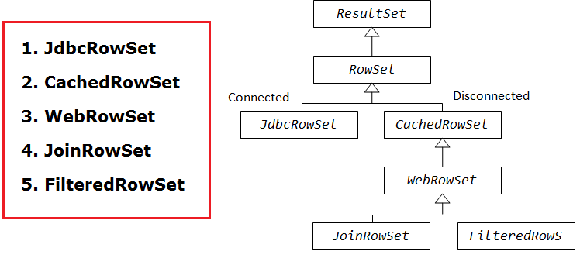
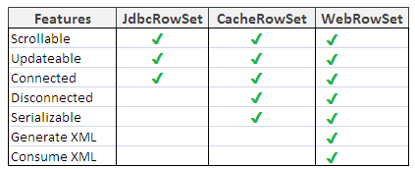

JdbcRowSet rowSet = RowSetProvider.newFactory().createJdbcRowSet();
rowSet.setUrl("jdbc:oracle:thin:@localhost:1521:xe");
rowSet.setUsername("system");
rowSet.setPassword("oracle");
rowSet.setCommand("select * from emp400");
rowSet.execute();

2.14 Notes

Servlets
A web application is an application accessible from the web. A web application is composed of web components like Servlet, JSP, Filter etc. and other components such as HTML. The web components typically execute in Web Server and respond to HTTP request.
1. CGI
CGI technology enables the web server to call an external program and pass HTTP request information to the external program to process the request. For each request, it starts a new process.
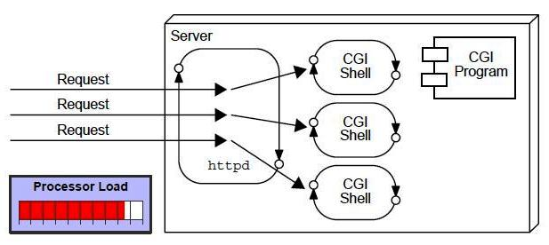
Disadvantages of CGI
- If number of client’s increases, it takes more time for sending response.
- For each request, it starts a process and Web server is limited to start processes.
- It uses platform dependent language e.g. C, C++, perl.

2. Servlet
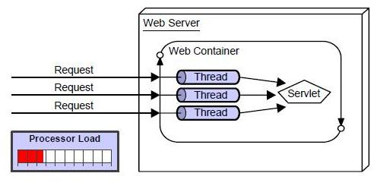
The web container creates threads for handling the multiple requests to the servlet.
- Better performance: because it creates a thread for each request not process.
- Portability: because it uses java language.
- Robust: Servlets are managed by JVM so we don't need to worry about memory leak, garbage collection etc.
- Secure: because it uses java language..

3.1 Basics of Web Technologies
Static Website | Dynamic Website
Prebuilt content is same every time the page is loaded. | Content is generated quickly and changes regularly.
It uses the HTML code for developing a website. | It uses the server side languages such as PHP,SERVLET, JSP, and ASP.NET etc. for developing a website.
It sends exactly the same response for every request. | It may generate different HTML for each of the request.
The content is only changes when someone publishes and updates the file (sends it to the web server). | The page contains "server-side" code it allows the server to generate the unique content when the page is loaded.

1. HTTP (Hyper Text Transfer Protocol)
HTTP is TCP/IP based communication protocol, which is used to deliver the data like image files, query results, HTML files etc on the World Wide Web (WWW) with the default port is TCP 80. It provides the standardized way for computers to communicate with each other.
There are three fundamental features that make the HTTP a simple and powerful protocol used for communication:
- HTTP is media independent: It refers to any type of media content can be sent by HTTP as long as both the server and the client can handle the data content.
- HTTP is connectionless: It is a connectionless approach in which HTTP client i.e., a browser initiates the HTTP request and after the request is sends the client disconnects from server and waits for the response.
- HTTP is stateless: The client and server are aware of each other during a current request only. Afterwards, both of them forget each other. Due to the stateless nature of protocol, neither the client nor the server can retain the information about different request across the web pages.
2. HTTP Requests
The request sends by the computer to a web server that contains all sorts of potentially interesting information is known as HTTP requests.
It will send following information to Server
- The analysis of source IP address, proxy and port
- The analysis of destination IP address, protocol, port and host
- The Requested URI (Uniform Resource Identifier)
- The Request method and Content
- The User-Agent header
- The Connection control header
We have following HTTP request methods:
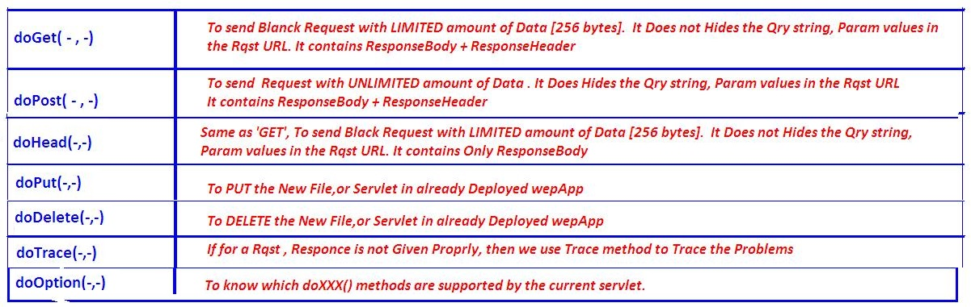

3. GET vs POST
GET | POST
1) In case of Get request, only limited amount of data can be sent because data is sent in header. | In case of post request, large amount of datacan be sent because data is sent in body.
2) Get request is not secured because data is exposed in URL bar. | Post request is secured because data is not exposed in URL bar.
3) Get request can be bookmarked. | Post request cannot be bookmarked.
4) Get request is idempotent. It means second request will be ignored until response of first request is delivered | Post request is non-idempotent.
5) Get request is more efficient and used more than Post. | Post request is less efficient and used less than get.

4. Servlet Container: is the place where Servlet programs are executed
The servlet container is used in java for dynamically generate the web pages on the server side. Therefore the servlet container is the part of a web server that interacts with the servlet for handling the dynamic web pages from the client.
The Servlet Container performs many operations that are given below:
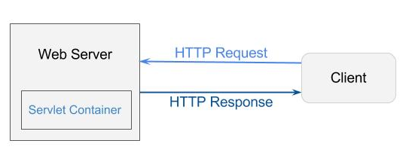
- Life Cycle Management
- Multithreaded support
- Object Pooling
- Security etc.

5. Web Server VS Application Server
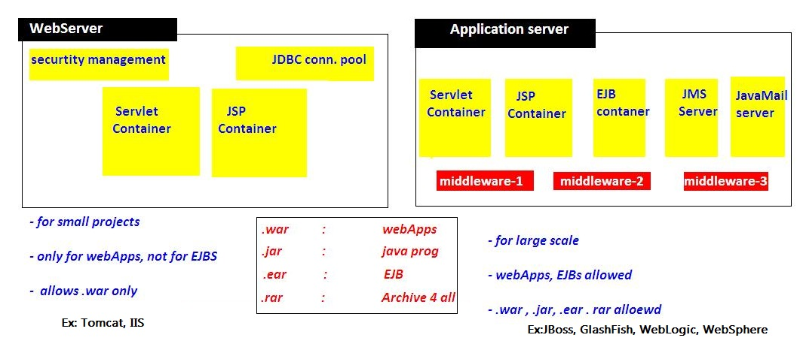

6. Content Type
Content Type is also known as MIME (Multipurpose internet Mail Extension) Type. It is a HTTP header that provides the description about what are you sending to the browser.
- It supports the non-ASCII characters
- It supports the multiple attachments in a single message
- It supports the attachment contains audio, images and video files etc.
- It supports the unlimited message length.

Commonly used content types are given below:

- text/html
- text/plain
- application/msword
- application/vnd.ms-excel
- application/jar
- application/pdf
- application/octet-stream
- application/x-zip
- images/jpeg
- images/png
- images/gif
- audio/mp3
- video/mp4
- Video/quicktime etc.

3.2 Servlet API
we can create any servlet program by using below 3 ways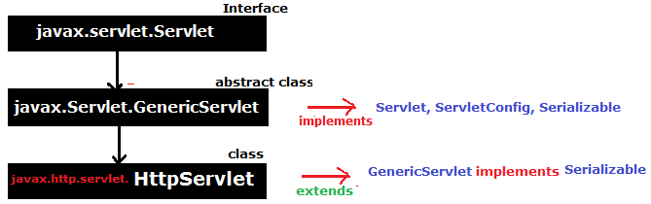

1. javax.servlet.Servlet (Interface)
Servlet interface is the ROOT interface of Servlet API. It provides common behaviour to all the servlets.
Method | Description
public void init(ServletConfig config) | Initializes the servlet. It is the life cycle method of servlet and invoked by the web container only once.
public void service(ServletRequest req,ServletResponse response) | Provides response for the incoming request. It is invoked at each request by the web container.
public void destroy() | Is invoked only once and indicates that servlet is being destroyed.
public ServletConfig getServletConfig() | Returns the object of ServletConfig.
public String getServletInfo() | returns information about servlet such as writer, copyright, version etc.

Steps to implement Servlet program using Servlet Interface
- Create a Class which implements Servlet Interface
- Implement all 5 abstract methods
- Write Request Processing logic in service(req,res) method

javax.servlet.GenericServlet (absraect class)
- GenericServlet class implements Servlet, ServletConfig and Serializable interfaces.
- It provides implementation for all methods of Servlet interface except the service().
- it is protocol-independent, so it can handle any request of any protocal
- Create servlet by providing the implementation of the service() method.

Init(),destroy(),getServletConfig(),getservletInfo() are inherted and implemented
1. public abstract void service(ServletRequest req, ServletResponse res)
2. public void init()
it is a convenient method for the servlet programmers, now there is no need to call super.init(config)
3. public ServletContext getServletContext()
4. public String getInitParameter(String name)
5. public Enumeration getInitParameterNames()
6. public String getServletName()

Steps to write Servlet Program using GenericServlet
- Create a Class which extends GenericServlet Interface
- Implement & Write Request Processing logic in service(req,res) method

3.javax.servlet.http.HttpServlet
HttpServlet class extends the GenericServlet class and implements Serializable interface. It provides http specific methods such as doGet, doPost, doHead, doTrace etc.
We have 2 service methods
- Public void service(ServletRequest req,ServletResponse res) dispatches the request to the protected service method by converting the request and response object into http type.
- protected void service(HttpServletRequest req,HttpServletResponse res)
Receives the request from the service method, and dispatches the request to the doXXX() method depending on the incoming http request type.
7 proreddoXXX (HttpServletRequest, HttpServletResponce) service methods
- protected void doGet(HttpServletRequest req, HttpServletResponse res)
- protected void doPost(HttpServletRequest req, HttpServletResponse res)
- protected void doHead(HttpServletRequest req, HttpServletResponse res)
- protected void doOptions(HttpServletRequest req, HttpServletResponse res)
- protected void doPut(HttpServletRequest req, HttpServletResponse res)
- protected void doTrace(HttpServletRequest req, HttpServletResponse res)
- protected void doDelete(HttpServletRequest req, HttpServletResponse res)

Steps to write Servlet Program using GenericServlet
- Create a Class which extends HttpServlet Interface
- Write Request Processing logic in service(req,res) OR Not Recommended
- Write Request Processing logic in doXXX(req,res) doGet,doPost Recommended

Servlet Lifecycle
First we see the example, then we can understand the LifeCycle. For every Servlet program contains following strcuture
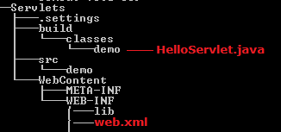 Here Servlets is Application name
Example 1: Using Servlet Interface

public class HelloServlet implements Servlet{
ServletConfig config = null;
@Override
public void init(ServletConfig config) throws ServletException {
this.config = config;
System.out.println("1.Init...");
}
@Override
public void service(ServletRequest req, ServletResponse res) throws ServletException, IOException {
System.out.println("2.Service ...");
PrintWriter pw = res.getWriter();
pw.write("<h1>Hello, World!</h1>");
}
@Override
public void destroy() {
System.out.println("3.Destroy ..");
}
@Override
public ServletConfig getServletConfig() {
System.out.println("4.getServletConfig ..");
return config;
}
@Override
public String getServletInfo() {
return "getServletInfo";
}
}

<?xml version="1.0" encoding="UTF-8"?>
<web-app>
<servlet>
<servlet-name>hello</servlet-name>
<servlet-class>demo.HelloServlet</servlet-class>
</servlet>

<servlet-mapping>
<servlet-name>hello</servlet-name>
<url-pattern>/hello</url-pattern>
</servlet-mapping>

<welcome-file-list>
<welcome-file>index.jsp</welcome-file>
</welcome-file-list>
</web-app>
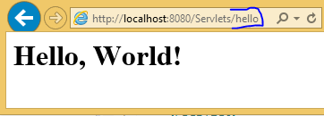

Flow of Excecution
- When ever we deploys the application, container loads the application & creates ServletContext Object & waits for the Request

- if we give <load-on-startup>1</load-on-startup> container will creates ServletConfig Object when the time of Deploying application

- when we give the url : http://localhost:8080/Servlets/hello , request goes to container, and it searches for /hello url pattern in web.xml

- web.xml searches for /hello , in <servlet-mapping> and gets Servelt-name

- container loads demo.HelloServlet class and creates creates ServletConfig Object and calls inti() method

- for every request it will calls service(req,res) method, for 100 requests it will execute 100 times

- destroy() method will be called before servlet is removed from the container, and finally it will be garbage collected as usual.
In above <load-on-startup>1</load-on-startup> we may give (1,2..10). based up on priority order it will creates the ServletConfig Object
<welcome-file-list>
- If we want to make any page/servlet as Homepage we have to specify in this tag
- If it contains more then 1 file, it will give priority by the Order
Example 2: Using GenericServlet

public class HelloServlet extends GenericServlet {
public void service(ServletRequest req, ServletResponse res) throws ServletException, IOException {
res.setContentType("text/html");
PrintWriter pw = res.getWriter();
pw.write("Hello, Generic Servlet");
}
}

Example 3: Using HttpServlet
public class HelloServlet extends HttpServlet {
@Override
public void service(ServletRequest req, ServletResponse res) throws ServletException, IOException {
System.out.println("Public Service ........");
}

@Override
protected void service(HttpServletRequest req, HttpServletResponse res) throws ServletException, IOException {
System.out.println("Protecd Service ........");
}

@Override
protected void doGet(HttpServletRequest req, HttpServletResponse resp) throws ServletException, IOException {
System.out.println("doGet() ....");
}

@Override
protected void doPost(HttpServletRequest req, HttpServletResponse resp) throws ServletException, IOException {
// TODO Auto-generated method stub
System.out.println("doPost() ....");
}
}
INFO: Reloading Context with name [/Servlets] is completed
Public Service........
- Container first calls public Service(req,res) method
- Public Service() method internally calls protected Service(req,res) method
- Protected Service() method will internally calling doGet() or doPost() or doXXX() depends on the type of http method used by the client
- If the client is not specifying the type of Http method then Http protocol by default consider GET method,
- so finally the client request is processed at doGet() method

3.4 ServletRequest (interface) getParamaters()
ServletRequest is send to Server to process particular request. It can send following details to servlet by submitting FORM or by URL.we can get these details at server side
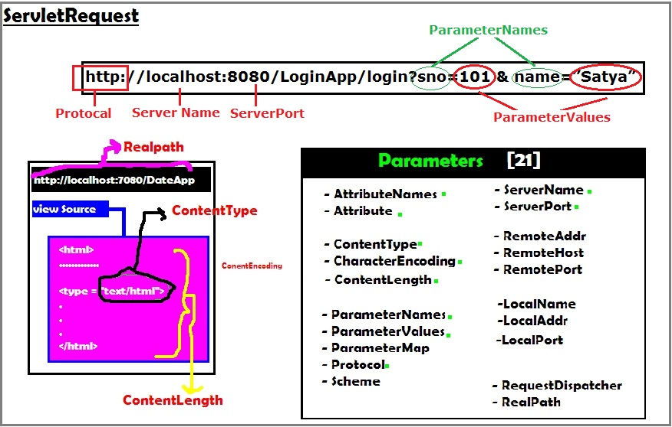
Example to getRequest details
public class ServletReq extends HttpServlet {
@Override
protected void doGet(HttpServletRequest req, HttpServletResponse res) throws ServletException, IOException {
res.setContentType("text/html");
PrintWriter pw = res.getWriter();
pw.println("<br> getProtocol \t:" + req.getProtocol());
pw.println("<br> getServerName \t:" + req.getServerName());
pw.println("<br> getServerPort \t:" + req.getServerPort());
pw.println("<br> getRemotePort \t:" + req.getRemotePort());
pw.println("<br> getLocalPort \t:" + req.getLocalPort());

pw.println("<br> getContentType \t:" + req.getContentType());
pw.println("<br> getContentLength \t:" + req.getContentLength());
pw.println("<br> CharacterEncoding\t:" + req.getCharacterEncoding());
pw.println("<br> req.getScheme \t:" + req.getScheme());
}
}
getProtocol :HTTP/1.1
getServerName :localhost
getServerPort :8080
getRemotePort :63205
getLocalPort :8080
getContentType :null
getContentLength :-1
CharacterEncoding :null
req.getScheme :http
We mainly use ServletRequest Object to retrieve data from FORM Submission or URL
We can get the paramaters by using following methods
- public String getParameter(“paramname”);
- public Enumeration getParameterNames();
- public String[] getParamterValues(“paramname”);
- public Map getParameterMap();

Example: getParamater ()
Index.html

<form action="login" method="get">
SNO:<input type="text" name="sno"><br>
NAME:<input type="text" name="name"><br>
<input type="submit" value="Submit">
</form>
LoginServlet.java
public class LoginServlet extends HttpServlet {
protected void doGet(HttpServletRequest req, HttpServletResponse res) throws ServletException, IOException {
PrintWriter pw = res.getWriter();
res.setContentType("text/html");
String sno = req.getParameter("sno");
String name = req.getParameter("name");
pw.println("<h1>Sno : " + sno);
pw.println("<br>Name : " + name);
pw.close();
}
}
<web-app
<servlet>
<servlet-name>login</servlet-name>
<servlet-class>demo.LoginServlet</servlet-class>
</servlet>
<servlet-mapping>
<servlet-name>login</servlet-name>
<url-pattern>/login</url-pattern>
</servlet-mapping>
</web-app>
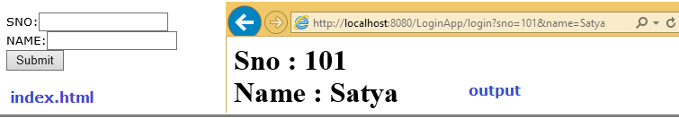
Make sure if we use GET method in form we must use doGet (Req, Res) & for POST we have to use doPost(req,res). Otherwise it throws Get/Post not supported error.in this type of case write logic doGet() & call doGet() in doPost()
public Enumeration getParameterNames();
Sometimes we don’t know the request parameter names, in this case we use getParameterNames ();. See the same UI for this only Servlet code is changed
public class LoginServlet extends HttpServlet {
protected void doPost(HttpServletRequest req, HttpServletResponse res) throws ServletException, IOException {
PrintWriter pw = res.getWriter();
res.setContentType("text/html");
Enumeration e = req.getParameterNames();
while (e.hasMoreElements()) {
String s = (String) e.nextElement();
pw.write("Param Name :" +s + ",Param Value : " + req.getParameter(s)+"<br>");
}
pw.close();
}
}
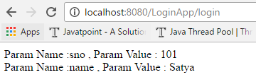
getParamterValues(“paramname”), getParameterMap(); are used in the case of Single parameter can having multiple values, like checkboxes. See below example
getParamterValues(“paramname”) Example

<form action="login" method="post">
NAME:<input type="text" name="name"><br>
Skills : <br>
<input type="checkbox" name="skill" value="java">JAVA<br>
<input type="checkbox" name="skill" value="cpp">CPP<br>
<input type="checkbox" name="skill" value="hadoop">HADOOP<br>
<input type="checkbox" name="skill" value="devops">DevOps<br>
<input type="submit" value="Submit">
</form>
public class LoginServlet extends HttpServlet {
protected void doPost(HttpServletRequest req, HttpServletResponse res) throws ServletException, IOException {
PrintWriter pw = res.getWriter();
res.setContentType("text/html");
pw.write("<h1> Name : " + req.getParameter("name"));
pw.write("<br> Skills : <br> ");
String[] skills = req.getParameterValues("skill");
for (int i = 0; i < skills.length; i++) {
pw.write(i + ". " + skills[i] + "<br>");
}
pw.close();
}
}
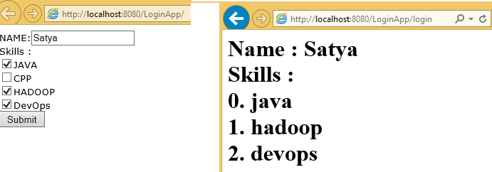
getParameterMap(); Example
public class LoginServlet extends HttpServlet {
protected void doPost(HttpServletRequest req, HttpServletResponse res) throws ServletException, IOException {
PrintWriter pw = res.getWriter();
res.setContentType("text/html");

Map m = req.getParameterMap();
Set s = m.entrySet();
Iterator it = s.iterator();

while (it.hasNext()) {
Map.Entry entry = it.next();

String key = entry.getKey();
String[] value = entry.getValue();
pw.println("Key is " + key + "<br>");

if (value.length > 1) {
for (int i = 0; i < value.length; i++) {
pw.println("<li>" + value[i].toString() + "</li><br>");
}
} else
pw.println("Value is " + value[0].toString() + "<br>");
pw.println("-------------------<br>");
}
pw.close();
}
}
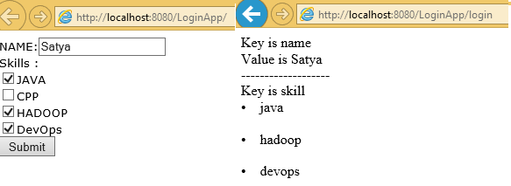

3.5 ServletConfig (interface) getInitParamaters()
- ServletConfig is one of the pre-defined interface.
- ServletConfig object exists one per servlet program.
- An object of ServletConfig created by the container during its initialization phase.
- An object of ServletConfig is available to the servlet during its execution, once the servlet execution is completed, automatically ServletConfig interface object will be removed by the container.
- It contains <init-param> details at web.xml, of a particular servlet.
- The moment when we are using an object of ServletConfig, we need to configure the web.xml by writing <init-param> tag under <servlet> tag of web.xml.

1. How to get ServletConfig Object
We can ServletConfig object in 2 ways
1. By calling getServletConfig() on current servlet
ServletConfig conf = getServletConfig();
Above method is available in Servlet interface, inherited in to GenericServlet & HttpServlet

2. ServletConfig object will be available in init() method of the servlet.
public void init(ServletConfig config)
{
// …………………
}

2. How to place <init-param> in web.xml
We have to place <init-param> in between <servlet> tags
<web-app>
<servlet>
<servlet-name>login</servlet-name>
<servlet-class>demo.LoginServlet</servlet-class>
<init-param>
<param-name>s1</param-name>
<param-value> 100 </param-value>
</init-param>

<init-param>
<param-name>s2</param-name>
<param-value>200</param-value>
</init-param>
</servlet>
<servlet-mapping>
<servlet-name>login</servlet-name>
<url-pattern>/login</url-pattern>
</servlet-mapping>
</web-app>
3.how to get Initparameters in Servlet Programe
We can retrieve <init-param> values by using following methods
- public String getInitParameter(“param name”);
- public Enumeration getInitParameterNames();
public class LoginServlet extends HttpServlet {
protected void doPost(HttpServletRequest req, HttpServletResponse res) throws ServletException, IOException {
PrintWriter pw = res.getWriter();
res.setContentType("text/html");

ServletConfig cfg = getServletConfig();
pw.write("<h3> 1. Using getInitParameter()");
pw.write("<br> s1 : " + cfg.getInitParameter("s1"));
pw.write("<br> s2 :" + cfg.getInitParameter("s2"));

pw.write("<br><br> 2. Using getInitParameterNames()");
Enumeration e = cfg.getInitParameterNames();
while (e.hasMoreElements()) {
String s = (String) e.nextElement();
pw.write("<br>" +s + "\t : " + cfg.getInitParameter(s));
}
}
}
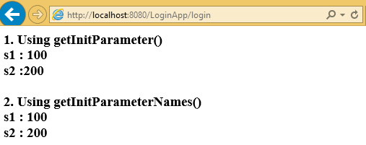

3.6 ServletContext (interface) getInitParamaters()
- Object of ServletContext interface is available one per web application.
- ServletContext object is automatically created by the container when the web application is deployed.
- <context-param> is placed between <web-app> tags. Because the paramaters can be accessed by all the servlets in the Web Application
1. how to get ServletContext Object
We have 3 ways
1. Using ServletConfig Object
ServletConfig conf = getServletConfig();
ServletContext context = conf.getServletContext();
2. By calling getServletContext() on GenericServlet
ServletContext ctx = getServletContext();
getServletContext () method is defined in GenericServlet
3. By calling getServletContext() on HttpServlet
ServletContext ctx = getServletContext();
getServletContext () method is defined in GenericServlet inherited to HttpServlet

2. How to place <context-param> in web.xml
<context-param> is placed between <web-app> tags. Because the paramaters can be accessed by all the servlets in the Web Application
<web-app>
<context-param>
<param-name>c1 </param-name>
<param-value>1000</param-value>
</context-param>

<context-param>
<param-name>c2 </param-name>
<param-value>200</param-value>
</context-param>

<servlet>
<servlet-name>login</servlet-name>
<servlet-class>demo.LoginServlet</servlet-class>
</servlet>
<servlet-mapping>
<servlet-name>login</servlet-name>
<url-pattern>/login</url-pattern>
</servlet-mapping>
<welcome-file-list>
<welcome-file>index.html</welcome-file>
</welcome-file-list>
</web-app>

3. how to context-params in Servlet Programe
We have two methods
- public String getInitParameter(“param name”);
- public Enumeration getInitParameterNames();

public class LoginServlet extends HttpServlet {
protected void doPost(HttpServletRequest req, HttpServletResponse res) throws ServletException, IOException {
PrintWriter pw = res.getWriter();
res.setContentType("text/html");

ServletConfig cfg = getServletConfig();
ServletContext context = cfg.getServletContext();

pw.write("<h3> 1. Using getInitParameter()");
pw.write("<br> s1 : " + context.getInitParameter("c1"));
pw.write("<br> s2 : " + context.getInitParameter("c2"));

pw.write("<br><br> 2. Using getInitParameterNames()");
Enumeration e = context.getInitParameterNames();
while (e.hasMoreElements()) {
String s = (String) e.nextElement();
pw.write("<br>" + s + "\t : " + context.getInitParameter(s));
}
}
}
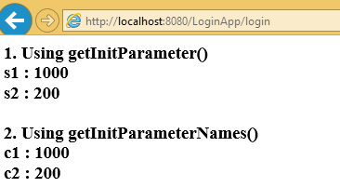
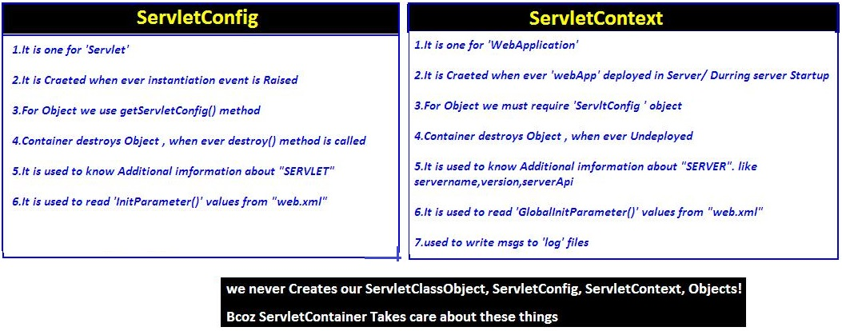

3.7 ServletChaining
Servlet chaining is used to achive Communication beween servlets. To perform this we have to use RequestDisptcher inferface .following are the possible ways to achive ServletChaining
- rd. forward(req, res)
- rd. include (req, res)
- res.sendRedirect(/url)

RequestDisptcher Interface
The RequestDispatcher interface provides the facility of dispatching the request to another resource it may be html, servlet or jsp. We have 2 main methods in this RequestDisptcher

- public void forward(ServletRequest req,ServletResponse res)
- public void include (ServletRequest req,ServletResponse res)

1. How to get RequestDisptcher Object
We have 3 ways to get RequestDisptcher object
- using Request object
RequestDispatcher rd = request.getRequestDispatcher("/url or servletname");
rd.forward(req, res);
rd.include(req, res);
If we use request object, the webresource programs are must be in same web application
- using ServletContext object with getRequestDispatcher(“url”) method
RequestDispatcher rd = context.getRequestDispatcher("/url or servletname");
rd.forward(req, res);
rd.include(req, res);
If we use Context object, the webresource programs are may in same/different web applictions

- using ServletContext object with getNamedDispatcher(“servletname”) method
RequestDispatcher rd = context. getNamedDispatcher("serv1");
rd.forward(req, res);
rd.include(req, res);

- /URL if we are placing .html, .jsp type of files we have to add ‘/’ in path
- Servltname if we are using logical names of servlet/jsp like serv1, serv2 etc, then we must not to add ‘/’ in path
RequestDispatcher | NamedDispatcher
Invokable on both request & context Objects  Exptects servlet url-pattren logical name or filenames of .html, .jsp files as argument  RequestDisptacher Object can points destination servlets,jsps & .html pages | Invokable only on context Object  Exptects only servlet url-pattren logical name as argument  RequestDisptacher Object can points only destination servlets,jsps but not .html pages
Servlet chaining in Same Server
We can use forward(), include() methods to perform chaining between two servlets which are resides in same web application or different web applications of same server
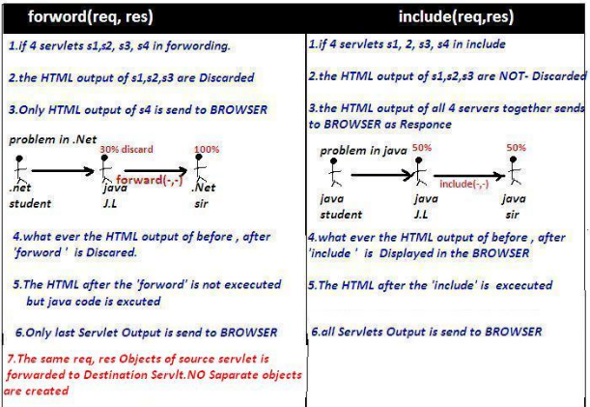
Forword() example
Input.html
<form action="s1" method="GET">
Number1 : <input type="text" name="n1"><br>
<input type="submit" value="SQURE">
</form>

Web.xml
<web-app>
<servlet>
<servlet-name>s1</servlet-name>
<servlet-class>demo.srv1</servlet-class>
</servlet>
<servlet>
<servlet-name>s2</servlet-name>
<servlet-class>demo.srv2</servlet-class>
</servlet>
<servlet-mapping>
<servlet-name>s1</servlet-name>
<url-pattern>/s1</url-pattern>
</servlet-mapping>
<servlet-mapping>
<servlet-name>s2</servlet-name>
<url-pattern>/s2</url-pattern>
</servlet-mapping>
</web-app>
public class srv1 extends HttpServlet {
public void doGet(HttpServletRequest req, HttpServletResponse res) throws ServletException, IOException {
ServletConfig cg = getServletConfig();
ServletContext sc = cg.getServletContext();
res.setContentType("text/html");
PrintWriter pw = res.getWriter();

String s1 = req.getParameter("n1");
int a = Integer.parseInt(s1);
int b = a * a;

pw.println("<h1>Before forword : " + b + "</h1>");
RequestDispatcher rd = sc.getRequestDispatcher("/s2");
rd.forward(req, res); // (1)
pw.println("<h1> After forword</h1>");
}

public void doPost(HttpServletRequest req, HttpServletResponse res) throws ServletException, IOException {
doGet(req, res);
}
}
public class srv2 extends HttpServlet {
public void doGet(HttpServletRequest req, HttpServletResponse res) throws ServletException, IOException {
res.setContentType("text/html");
PrintWriter pw = res.getWriter();
String s1 = req.getParameter("n1");
int a = Integer.parseInt(s1);
int b = a * a;
pw.println("<h1>Squre from SRV2 : " + b + "</h1>");
}
public void doPost(HttpServletRequest req, HttpServletResponse res) throws ServletException, IOException {
doGet(req, res);
}
}
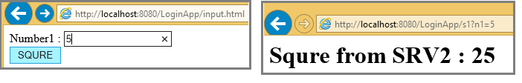
In above (1), if we just replace with include(req, res) as below it include serv1 result also
RequestDispatcher rd = sc.getRequestDispatcher("/s2");
rd.include(req, res);
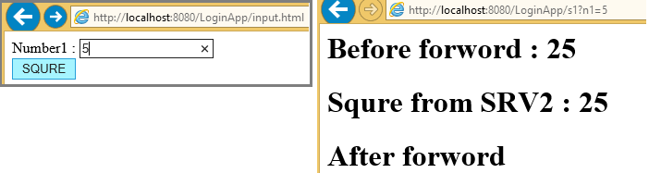
Servlet chaining in Different Server 314 page in natraj
We can use res.sendRedirect(url) method to perform chaining between two servlets which are running on different servers
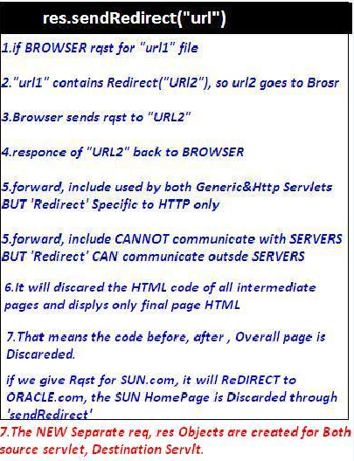
public class srv3 extends HttpServlet {
public void doGet(HttpServletRequest req, HttpServletResponse res) throws ServletException, IOException {
res.setContentType("text/html");
PrintWriter pw = res.getWriter();
pw.println("<h1>Before sendReditrect</h1>");
res.sendRedirect("http://www.google.com");
pw.println("<h1>After sendReditrect</h1>");

}
public void doPost(HttpServletRequest req, HttpServletResponse res) throws ServletException, IOException {
doGet(req, res);
}
}
forward() method | sendRedirect() method
The forward() method works at server side. | The sendRedirect() method works at client side.
It sends the same request and response objects to another servlet. | It always sends a new request.
It can work within the server only.  Example: request.getRequestDispacher("servlet2").forward(request,response); | It can be used within and outside the server.  Example: response.sendRedirect("servlet2");

3.8 Attribbutes
The servlet programmer can pass informations from one servlet to another using attributes. It is just like passing object from one class to another so that we can reuse the same object again and again.
We have 3 types of scopes for attribues
- Request scope
- Session scope
- Application scope (ServletContext Scope)
Attributes can be apply
- if Both Source& Destination Servlets are in same/difffrent webapplication
- if Both Source& Destination Servlets are in same Server
- It is not applicable if Both Source& Destination Servlets are in different Server

We have 3 methods to deal with attribues
- public void setAttribute(String name,Object object
- public Object getAttribute(String name)
- public void removeAttribute(String name)

1. Request Attribute: It applicable only if both servlets must be in CHAIN
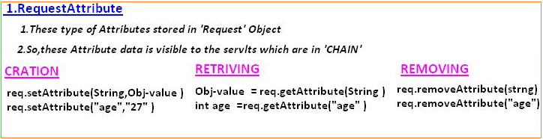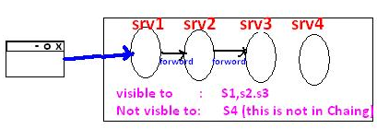
public class srv1 extends HttpServlet {
public void doGet(HttpServletRequest req, HttpServletResponse res) throws ServletException, IOException {
req.setAttribute("uname", "ADMIN");
req.setAttribute("pwd", "123abc$");
RequestDispatcher rd = req.getRequestDispatcher("/s2");
rd.forward(req, res);
}
}
public class srv2 extends HttpServlet {
public void doGet(HttpServletRequest req, HttpServletResponse res) throws ServletException, IOException {
res.setContentType("text/html");
PrintWriter pw = res.getWriter();
pw.write("Username : "+req.getAttribute("uname"));
pw.write("Password : "+req.getAttribute("pwd"));
}
}
Output: Username: ADMIN Password : 123abc$

2. Session Attribute: It applicable per one browser window at a time. I.e Session is maintain in single window
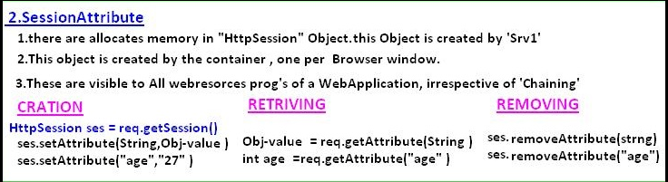
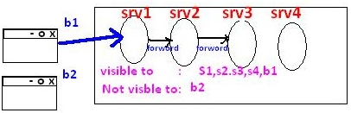
public class srv1 extends HttpServlet {
public void doGet(HttpServletRequest req, HttpServletResponse res) throws ServletException, IOException {
HttpSession sess = req.getSession();
sess.setAttribute("id", "10001");
sess.setAttribute("name", "Satya");
}
}
public class srv2 extends HttpServlet {
public void doGet(HttpServletRequest req, HttpServletResponse res) throws ServletException, IOException {
res.setContentType("text/html");
PrintWriter pw = res.getWriter();
HttpSession sess = req.getSession();
pw.write("ID : "+sess.getAttribute("id"));
pw.write("<br>Name : "+sess.getAttribute("name"));
}
}
Output ID : 10001 Name : Satya
3. Application /Context Attribute
- It can applicable both servelts must be in Single Server
- No need of Servlet Chaining & Session because it is per web application
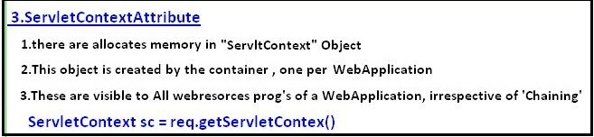
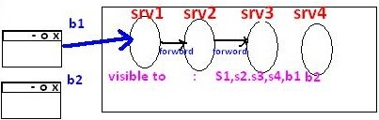
public class srv1 extends HttpServlet {
public void doGet(HttpServletRequest req, HttpServletResponse res) throws ServletException, IOException {
ServletContext cxt= req.getServletContext();
cxt.setAttribute("name", "Johnny");
cxt.setAttribute("age", "26");
}
}

public class srv2 extends HttpServlet {
public void doGet(HttpServletRequest req, HttpServletResponse res) throws ServletException, IOException {
res.setContentType("text/html");
PrintWriter pw = res.getWriter();
ServletContext cxt= req.getServletContext();
pw.write("Name: "+cxt.getAttribute("name"));
pw.write("Age : "+cxt.getAttribute("age"));
}
}
Output: Name: Johnny Age : 26
Stateless Behaviour: is nothing but while processing current request in any web resource program is cannot use previous request data is nothing but Statteless here.
HTTP is a Stateless protocol that means each request is considered as the new request
To make our HttpServlet as a Statefull resource program we use Session Tracking

3.9 Session Tracking
Session Tracking is a way of remembering clinet data across the multiple requests during a session.
There are 4 techniques used in Session tracking:
- Hidden Form Field
- Cookies
- HttpSession
- URL Rewriting
1. Hidden Form Field
- We store the information in the hidden field and get it from another servlet
- <input type="hidden" name="uname" value="Satya">
- It easy to write
Disadvantages
- Used only on TextBoxes
- If we see the view-source of html page, the hidden values can visible
- Not secure

<form action = "s1" method = "get">
Name : <input type = "text" name = "name"><br>
Age : <input type = "text" name = "age"><br>
Marrige : <input type = "checkbox" name = "mrg" value = "yes"><br>
<input type = "submit" name = "btn" value = "NEXT"> <br>
</form>
public class srv1 extends HttpServlet {
public void service(HttpServletRequest req, HttpServletResponse res) throws ServletException, IOException {
res.setContentType("text/html");
PrintWriter pw = res.getWriter();

String name = req.getParameter("name");
String age = req.getParameter("age");
String mrg = req.getParameter("mrg");

if (mrg == null) {
mrg = "single";
pw.println("<form action = 's2'>");
pw.println("Why do u want to marry :<input type='text' name = 'why'><br>");
pw.println("<input type = 'hidden' name = 'name' value = " + name + ">");
pw.println("<input type = 'hidden' name = 'age' value = " + age + ">");
pw.println("<input type = 'hidden' name = 'mrg' value = " + mrg + ">");
pw.println("<input type = 'submit' name = 'btn' value = 'OK'><br>");
pw.println("</form>");
}

else {
mrg = "married";
pw.println("<form action = 's2'>");
pw.println("How Many Childrens:<input type = 'text' name = 'child'><br>");
pw.println("<input type = 'hidden' name = 'name' value = " + name + ">");
pw.println("<input type = 'hidden' name = 'age' value = " + age + ">");
pw.println("<input type = 'hidden' name = 'mrg' value = " + mrg + ">");
pw.println("<input type = 'submit' name = 'btn' value = 'OK'><br>");
pw.println("</form>");
}
}
}
public class srv2 extends HttpServlet {
public void doGet(HttpServletRequest req, HttpServletResponse res) throws ServletException, IOException {
res.setContentType("text/html");
PrintWriter pw = res.getWriter();
pw.println("<h3> Status of yours...........</h1>");
pw.println("<h4> Name :" + req.getParameter("name"));
pw.println("<br> Age :" + req.getParameter("age"));
pw.println("<br> Status :" + req.getParameter("mrg"));

if (req.getParameter("mrg").equals("single")) {
pw.println("<br> Reason :" + req.getParameter("why"));
}else{
pw.println("<br> No.of Childrents :"+ req.getParameter("child"));
}
}
}
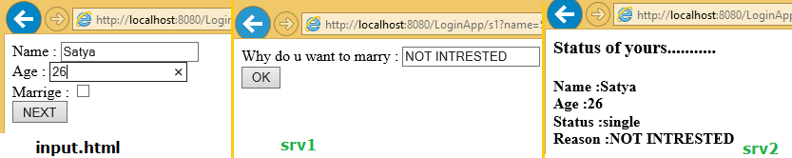
2. Cookies
A cookie is a small piece of information saved in the browser between the multiple client requests.
There are 2 types of cookies in servlets.
- Non-persistent cookie
- Persistent cookie 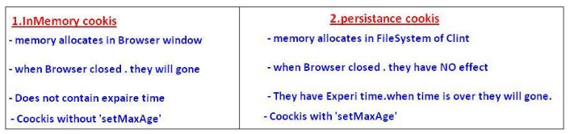
Advantage of Cookies
- Simplest technique of maintaining the state.
- Cookies are maintained at client side.
Disadvantage of Cookies
- It will not work if cookie is disabled from the browser.
- Only textual information can be set in Cookie object.
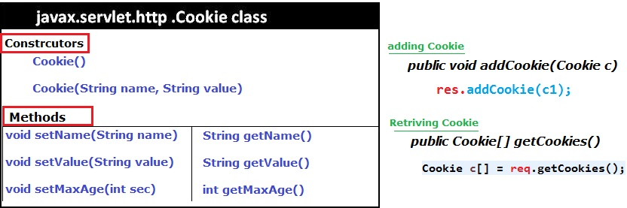
public class srv1 extends HttpServlet {
public void service(HttpServletRequest req, HttpServletResponse res) throws ServletException, IOException {
res.setContentType("text/html");
PrintWriter pw = res.getWriter();
Cookie c1 = new Cookie("name", "Satya");
Cookie c2 = new Cookie("age", "28");
c1.setMaxAge(5000); //max 5 sec alive
res.addCookie(c1);
res.addCookie(c2);
pw.write("<h3>Cookies Added!");
}
}
public class srv2 extends HttpServlet {
public void doGet(HttpServletRequest req, HttpServletResponse res) throws ServletException, IOException {
res.setContentType("text/html");
PrintWriter pw = res.getWriter();
Cookie c[] = req.getCookies();
pw.println("<h4> Cookie Name : Cookie Value </h4>");
for (int i = 0; i < c.length; i++) {
pw.println(c[i].getName() + " : " + c[i].getValue());
}
}
}
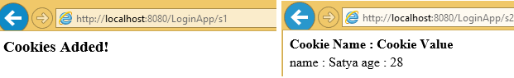
3. Http Session
- HttpSession Object memory allocates in Server
- it remembers the client data across the multiple requests in the form of Session Attribute values
- Every Session object contains SessionID, & stored in browser.
- Session of a browser can be identified by SessionID.
Constrcurors
- public HttpSession getSession():
- Returns the current session associated with this request
- If the request does not have a session, creates one.

- public HttpSession getSession(boolean create
- Returns the current session associated with this request
- True request does not have a session, creates new session.
- False request does not have a session, it wont create new session

Methods
- public String getId() :Returns a string containing the unique identifier value.
- public long getCreationTime() :Returns the time when this session was created
- public long getLastAccessedTime():Returns the last time the client sent a
- public void invalidate(): Invalidates this session then unbinds any objects bound to it.
public class srv1 extends HttpServlet {
public void service(HttpServletRequest req, HttpServletResponse res) throws ServletException, IOException {
res.setContentType("text/html");
PrintWriter pw = res.getWriter();
HttpSession ses = req.getSession();
ses.setAttribute("name", "Ravi");
ses.setAttribute("city", "HYD");
pw.write("<h3>Session Added!");
}
}
public class srv2 extends HttpServlet {
public void doGet(HttpServletRequest req, HttpServletResponse res) throws ServletException, IOException {
res.setContentType("text/html");
PrintWriter pw = res.getWriter();
HttpSession sess = req.getSession();
pw.write("Name : "+sess.getAttribute("name"));
pw.write("City : "+sess.getAttribute("city"));
}
}
Output : Name : Ravi , City : HYD

4. URL Rewriting
In URL rewriting, we append a token or identifier to the URL of the next Servlet or the next resource.
We can send parameter name/value pairs using the following format:
url?name1=value1&name2=value2&??
Advantage of URL Rewriting
- It will always work whether cookie is disabled or not (browser independent).
- Extra form submission is not required on each pages.
Disadvantage of URL Rewriting
- It will work only with links.
- It can send only textual information.
- Not Secure, user can read the information what we are sending
<form action="servlet1">
Name:<input type="text" name="userName"/><br/>
<input type="submit" value="go"/>
</form>

public class FirstServlet extends HttpServlet {

public void doGet(HttpServletRequest request, HttpServletResponse response){

response.setContentType("text/html");
PrintWriter out = response.getWriter();

String n=request.getParameter("userName");
out.print("Welcome "+n);

//appending the username in the query string
out.print("<a href='servlet2?uname="+n+"'>visit</a>");

out.close();
}
}

public class SecondServlet extends HttpServlet {

public void doGet(HttpServletRequest request, HttpServletResponse response)
response.setContentType("text/html");
PrintWriter out = response.getWriter();

//getting value from the query string
String n=request.getParameter("uname");
out.print("Hello "+n);
out.close();
}
}

3.10 Filters
A filter is invoked at the preprocessing and postprocessing of a request.
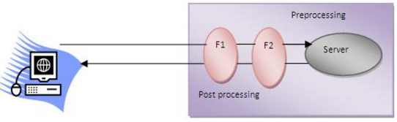
Filter is defined in the web.xml file, if we remove the entry of filter from the web.xml file, filter will be removed automatically and we don't need to change the servlet. So it will be easier to maintain the web application.
Usage of Filter
- recording all incoming requests
- logs the IP addresses of the computers from which the requests originate
- conversion
- data compression
- encryption and decryption
- Input validation etc.
Advantage of Filter
- Filter is pluggable.
- One filter don't have dependency onto another resource.
- Less Maintenance
Filter API
Like servlet filter have its own API.The javax.servlet package contains the 3 interfaces
- Filter
- FilterChain
- FilterConfig
1) Filter interface
For creating any filter, you must implement the Filter interface.Filter interface provides the life cycle methods for a filter.
Method | Description
public void init(FilterConfig config) | init() method is invoked only once. It is used to initialize the filter.
Public void doFilter(HttpServletRequest req,HttpServletResponse res, FilterChain chain) | doFilter() method is invoked every time when user request to any resource, to which the filter is mapped.It is used to perform filtering tasks.
public void destroy() | This is invoked only once when filter is taken out of the service.

2) FilterChain interface
The object of FilterChain is responsible to invoke the next filter or resource in the chain.This object is passed in the doFilter method of Filter interface.The FilterChain interface contains only one method:
public void doFilter(HttpServletRequest, HttpServletResponse):
It passes the control to the next filter or resource.
Example
index.html
<a href="servlet1">click here</a>

public class MyFilter implements Filter{

public void init(FilterConfig arg0) throws ServletException {}

public void doFilter(ServletRequest req, ServletResponse resp, FilterChain chain) throws IOException, ServletException {

PrintWriter out=resp.getWriter();
out.print("filter is invoked before");

chain.doFilter(req, resp);//sends request to next resource

out.print("filter is invoked after");
}
public void destroy() {}
}

public class HelloServlet extends HttpServlet {
public void doGet(HttpServletRequest request, HttpServletResponse response)
throws ServletException, IOException {

response.setContentType("text/html");
PrintWriter out = response.getWriter();

out.print("<br>welcome to servlet<br>");
}
}

<web-app>

<servlet>
<servlet-name>s1</servlet-name>
<servlet-class>HelloServlet</servlet-class>
</servlet>

<servlet-mapping>
<servlet-name>s1</servlet-name>
<url-pattern>/servlet1</url-pattern>
</servlet-mapping>

<filter>
<filter-name>f1</filter-name>
<filter-class>MyFilter</filter-class>
</filter>

<filter-mapping>
<filter-name>f1</filter-name>
<url-pattern>/servlet1</url-pattern>
</filter-mapping>

</web-app>

FilterConfig
An object of FilterConfig is created by the web container. This object can be used to get the configuration information from the web.xml file.
- public void init(FilterConfig config): init() method is invoked only once it is used to initialize the filter.
- public String getInitParameter(String parameterName): Returns the parameter value for the specified parameter name.
- public java.util.Enumeration getInitParameterNames(): Returns an enumeration containing all the parameter names.
- public ServletContext getServletContext(): Returns the ServletContext object
<filter>
<filter-name>f1</filter-name>
<filter-class>MyFilter</filter-class>
<init-param>
<param-name>age</param-name>
<param-value>27</param-value>
</init-param>
</filter>

<filter-mapping>
<filter-name>f1</filter-name>
<url-pattern>/servlet1</url-pattern>
</filter-mapping>

Servlet with Annotation (feature of servlet3):
- Annotation represents the metadata.
- If you use annotation, deployment descriptor (web.xml file) is not required.
- But you should have tomcat7 as it will not run in the previous versions of tomcat.
@WebServlet(“/url”) annotation is used to map the servlet with the specified name.
@WebServlet("/Simple")
public class Simple extends HttpServlet {
private static final long serialVersionUID = 1L;

protected void doGet(HttpServletRequest request, HttpServletResponse response)
throws ServletException, IOException {

response.setContentType("text/html");
PrintWriter out=response.getWriter();

out.print("<html><body>");
out.print("<h3>Hello Servlet</h3>");
out.print("</body></html>");
}
}
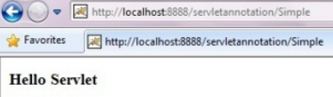

JSP

1. JSP Introduction
Features of JSP
- Extension to Servlet
- Easy to maintain
- Fast Development: No need to recompile and redeploy
- Less code than Servlet

JSP Architecure
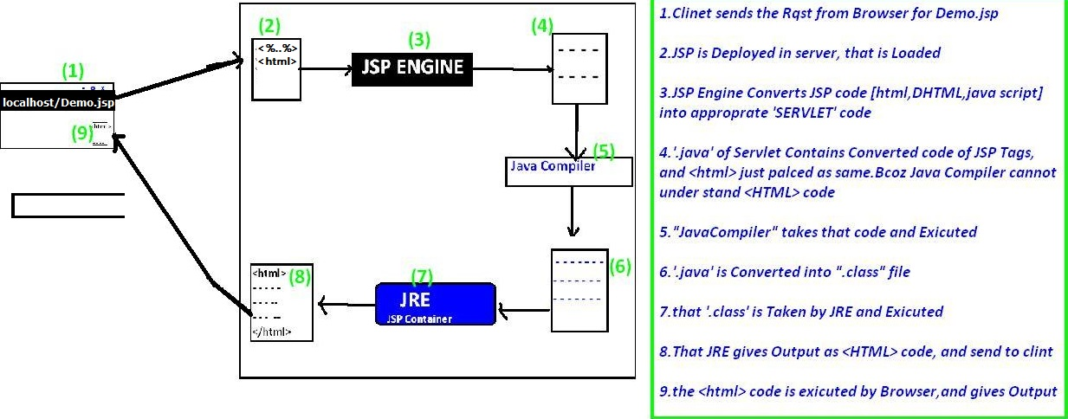
JSP Lifecycle
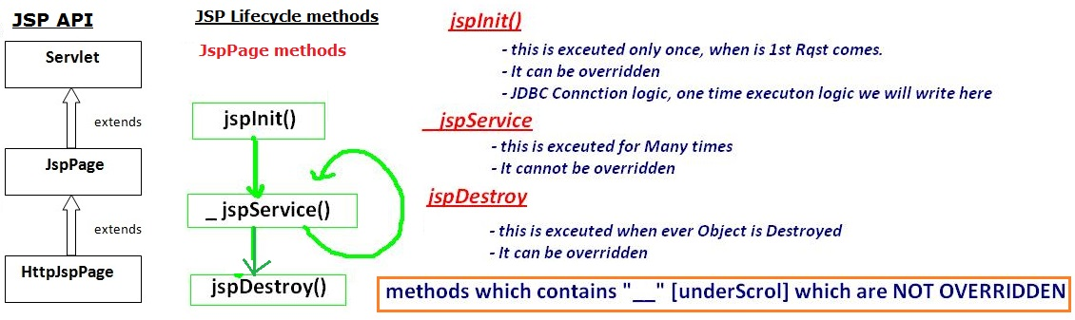

2. JSP Scriptlets
In JSP, java code can be written inside the jsp page using the scriptlet tag
The scripting elements provides the ability to insert java code inside the jsp. There are three types of scripting elements:
- scriptlet tag
- expression tag
- declaration tag
1. Scriptlet tag
A scriptlet tag is used to execute java source code in JSP. Syntax is as follows:
<% java source code %>

<html>
<body>
<%
out.print("welcome to jsp");
%>
</body>
</html>
Output: welcome to jsp
It is placed in _JspService () method. So method declarations not possible

2. Expression tag
It is mainly used for printing calculations, print the values of variable or method. The code placed within JSP expression tag is written to the output stream of the response. So you need not write out.print () to write data. Below is the syntax
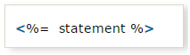
<html>
<body>
Date:<%=java.util.Calendar.getInstance().getTime()%>
</body>
</html>
Date:Thu Sep 22 19:10:14 IST 2016

It is placed in JspInit() method.
: Do not end your statement with semicolon in case of expression tag.

3. Declaration tag
- The JSP declaration tag is used to declare fields and methods.
- Code written inside the jsp declaration tag is placed outside the service() method
Variable Declaration

<html>
<body>
<%!int data = 50;%>
<%="Value of the variable is:" + data%>
</body>
</html>

Method Declaration
<html>
<body>
<%!
int cube(int n){
return n*n*n;
}
%>

<%="Cube of 3 is:" + cube(3)%>
</body>
</html>

3. JSP Implicit objects
There are 9 jsp implicit objects. These objects are created by the web container that are available to all the jsp pages.
Object | Type
out | JspWriter
request | HttpServletRequest
response | HttpServletResponse
config | ServletConfig
application | ServletContext
session | HttpSession
pageContext | PageContext
page | Object
exception | Throwable
Index.jsp
<%
out.print("1.welcome to jsp");

String name=request.getParameter("a");
out.print("<br> 2.Request :"+name);

response.sendRedirect("http://www.google.com");
out.print("3.Responce : ");

String cfg=config.getInitParameter("config");
out.print("<br> 4.Config ="+cfg);

String cxt=application.getInitParameter("context");
out.print("<br> 5.Application ="+cfg);

session.setAttribute("user","Satya");
out.print("<br> 6.Session ="+session.getAttribute("user"));
%>
<web-app>
<servlet>
<servlet-name>jsp</servlet-name>
<jsp-file>/index.jsp</jsp-file>
<init-param>
<param-name>config</param-name>
<param-value>iam Config Value</param-value>
</init-param>
</servlet>

<servlet-mapping>
<servlet-name>jsp</servlet-name>
<url-pattern>/jsp</url-pattern>
</servlet-mapping>

<context-param>
<param-name>context</param-name>
<param-value>iam Context Value</param-value>
</context-param>

</web-app>

7) pageContext implicit object
The pageContext object can be used to set, get or remove attributes from one of the following scopes:
- Page PageContext.PAGE_SCOPE
- Request PageContext.REQUEST_SCOPE
- Session PageContext.SESSION_SCOPE
- Application PageContext.APPLICATION_SCOPE
pageContext.setAttribute("name",” value”,PageContext.SESSION_SCOPE);

first.jsp
<html>
<body>
<%

String name=request.getParameter("uname");
out.print("Welcome "+name);

pageContext.setAttribute("user",name,PageContext.SESSION_SCOPE);

<a href="second.jsp">second jsp page</a>

%>
</body>
</html>

Second.jsp
<html>
<body>
<%
String name=(String)pageContext.getAttribute("user",PageContext.SESSION_SCOPE);
out.print("Hello "+name);
%>
</body>
</html>

8. Page implicit object
Page is an implicit object of type Object class
9. Exception
- Exception is an implicit object of type java.lang.Throwable class.
- This object can be used to print the exception.
- it can only be used in error pages
<%@ page isErrorPage="true" %>
<html>
<body>

Sorry following exception occured:<%= exception %>

</body>
</html>

4. JSP Directives
The jsp directives are messages that tells the web container how to translate a JSP page into the corresponding servlet.
There are three types of directives:
- page directive
- include directive
- taglib directive

1. Page Directive
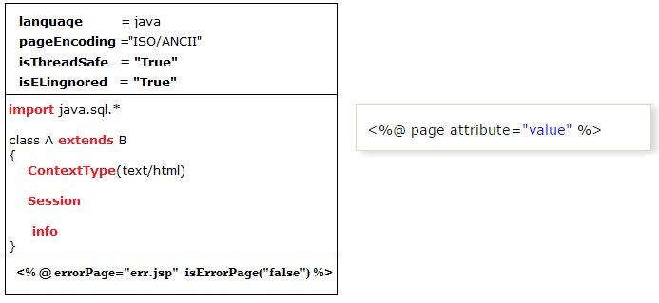
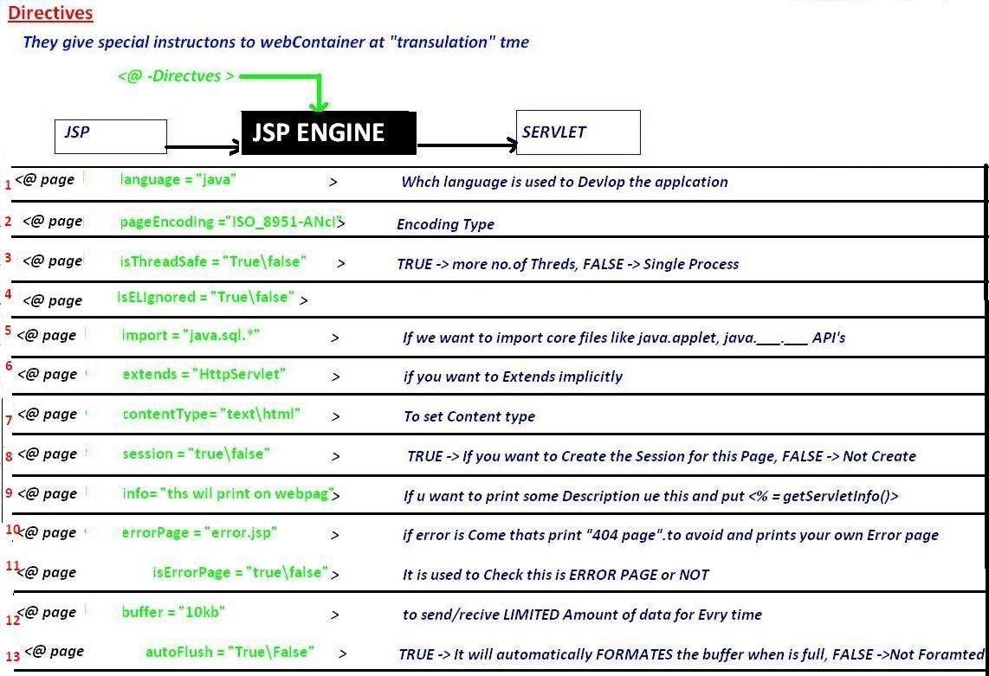

<%@ page language="java" %>
<%@ page pageEncoding="ISO-8859-1"%>
<%@ page isELIgnored="false"%>
<%@ page isThreadSafe="true"%>
<%@ page errorPage="err.jsp" isErrorPage="false"%>
<%@ page import="java.lang.*"%>
<%@ page extends="java.lang.Object"%>
<%@ page contentType="text/html"%>
<%@ page session="true"%>
<%@ page info="Some Info Print on web page"%>
<%@ page buffer="8kb"%>
<%@ page autoFlush="true"%>

2. include directive
The include directive is used to include the contents of any resource it may be jsp file, html file or text file. The include directive includes the original content of the included resource at page translation time (The jsp page is translated only once so it will be better to include static resource).

In this example, we are including the content of the header.html file. To run this example you must create a header.html file.
<html>
<body>

<%@ include file="header.html" %>

Today is: <%= java.util.Calendar.getInstance().getTime() %>

</body>
</html>
The include directive includes the original content, so the actual page size grows at runtime.

3. TagLib directive
- The JSP taglib directive is used to define a tag library that defines many tags.
- We use the TLD (Tag Library Descriptor) file to define the tags.
- We can insert custom tags by using this.
<html>
<body>
<%@ taglib uri="http://www.javatpoint.com/tags" prefix="mytag" %>
<mytag:currentDate/>
</body>
</html>

5. JSP Action Tags
The action tags are used to control the flow between pages and to use Java Bean. The Jsp action tags are given below.
JSP Action Tags | Description
jsp:forward | Forwards the request and response to another resource.
jsp:include | Includes another resource.
jsp:param | Sets the parameter value. It is used in forward and include mostly.
jsp:useBean | Creates or locates bean object.
jsp:setProperty | Sets the value of property in bean object.
jsp:getProperty | Prints the value of property of the bean.
jsp:plugin | Embeds another components such as applet.
jsp:fallback | Can be used to print the message if plugin is working. It is used in jsp: plugin.

Forward, include, param example
Login.jsp
<h2>Login Page</h2>

<jsp:include page="Success.jsp">
<jsp:param name="uname" value="ADMIN" />
<jsp:param name="pwd" value="admin" />
</jsp:include>
Success.jsp
<h2>Success Page</h2>
Welcome, <%= request.getParameter("uname") %>
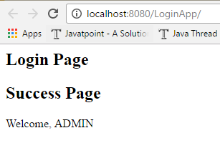Similarly we can use for <jsp:forward> also

UserBean Example
1. First we have choose the Input values for the Login page
<form action="set.jsp" method="post">
Email <input type="text" name="email"><br>
Pass <input type="text" name="pwd"><br>
<input type="submit" value="Login"><br>
</form>

2. We have to create UserBean class as per Input page parameters (email, pwd)
public class UserBean {
String email;
String pwd;
public String getEmail() {
return email;
}
public void setEmail(String email) {
this.email = email;
}
public String getPwd() {
return pwd;
}
public void setPwd(String pwd) {
this.pwd = pwd;
}
}

3. UserBean will set the values automatically by comparing property names
<jsp:useBean id="user" class="demo.UserBean">
<jsp:setProperty name="user" property="email"/>
<jsp:setProperty name="user" property="pwd"/>
</jsp:useBean>

<h3>getProperty Details</h3>
<jsp:getProperty name="user" property="email" /><br>
<jsp:getProperty name="user" property="pwd" /><br>
Here name is Object of bean class. & propery is the userbean property names
Output
getProperty Details
satyajohnny1@gmail.com
qw

jsp:plugin, jsp:fallbacks
The jsp:plugin action tag is used to embed applet in the jsp file.
<jsp:plugin height="500" width="500" type="applet" code="MouseDrag.class" />

jsp:fallback action tag is used to display some message if Applet is not loading
<jsp:fallback>
<p> Unable to start plugin </p>
</jsp:fallback>

6. JSP EL (JSP Expression Language)
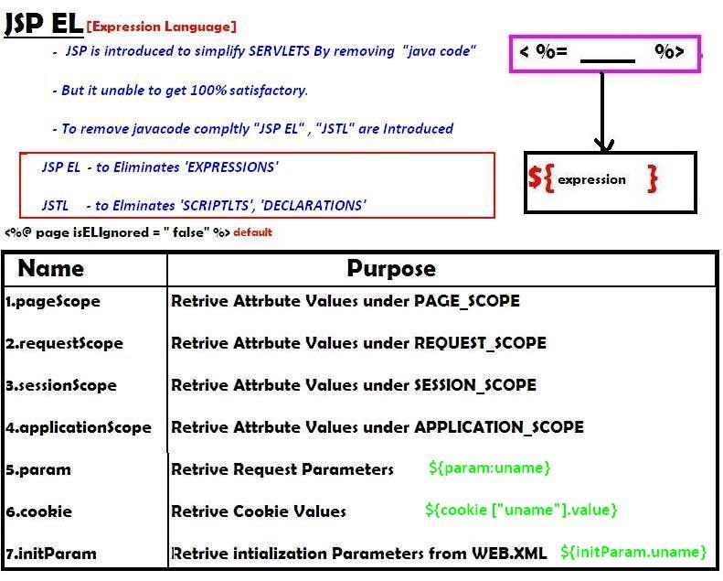
It simplifies for retrieving following types values mainly
- Request Paramters req.getParamter(“”)
- Init Patamter values getInitParameter(“”)
- Attribute Values getAttribute(“”) in 4 scopes
- Cookie values getCookie(“”)
<form action="jspel.jsp" method="post">
Name <input type="text" name="name"><br>
<input type="submit" value="Login"><br>
<%
session.setAttribute("pwd", "123456");
%>
</form>

Jspel.jsp
Name : ${ param.name }
Session: ${sessionScope.pwd}

7. JSP - Standard Tag Library (JSTL)
- JSP Standard Tag Library (JSTL) is a standard library of readymade tags.
- The JSTL contains several tags already implemented common functionalities.
- JSTL is external tags it is not come by default with JDK.we have to download jstl.jar seperatly and placed in lib/ folder
The JSTL tags can be classified, according to their functions, into following JSTL tag library groups that can be used when creating a JSP page:
- Core Tags used for import,if, foreach loops
- Formatting tags used for formatting text, Date,number,URLencoding
- SQL tags Used for SQL operations like INSERT,SELECT., etc
- XML tags provides support for XML processing
- JSTL Functions provides support for string manipulation.
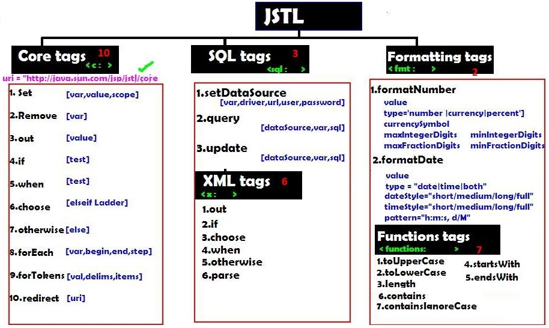
1. core tags
we have to attach jstl/core url at the top of the jsp as below
<%@ taglib uri="http://java.sun.com/jsp/jstl/core" prefix="c" %>

<%@ taglib uri="http://java.sun.com/jsp/jstl/core" prefix="c" %>
<c:set var="salary" scope="session" value="${2000*2}"/>
Salary : <c:out value="${salary}"/>

<c:if test="${salary > 2000}">
<p>My salary is: <c:out value="${salary}"/><p>
</c:if>
<!-- it is like if-else loop -->
<c:choose>
<c:when test="${salary <= 0}">
Salary is very low to survive.
</c:when>
<c:when test="${salary > 1000}">
Salary is very good.
</c:when>
<c:otherwise>
No comment sir...
</c:otherwise>
</c:choose>

<!-- it is mainly used on Number prints[1,2,3,4,5]-->
<c:forEach var="i" begin="1" end="5">
<c:out value="${i}"/><p>
</c:forEach>

<!-- it is mainly used on String-->
<c:forTokens items="Zara,nuha,roshy" delims="," var="name">
<c:out value="${name}"/><p>
</c:forTokens>

<c:remove var="salary"/>
<br>Salary : <c:out value="${salary}"/>

2. SQL Tags
<sql:setDataSource var="con" driver="com.mysql.jdbc.Driver"
url="jdbc:mysql://localhost/TEST"
user="root" password="pass123"
<sql:setDataSource/>

<sql:update dataSource="${con}" var="count">
INSERT INTO Employees VALUES (104, 2, 'Nuha', 'Ali');
</sql:update>

<sql:query dataSource="${snapshot}" var="result">
SELECT * from Employees;
</sql:query>

<c:forEach var="row" items="${result.rows}">
<tr>
<td><c:out value="${row.id}"/></td>
<td><c:out value="${row.first}"/></td>
<td><c:out value="${row.last}"/></td>
<td><c:out value="${row.age}"/></td>
</tr>
</c:forEach>

3. Formatting Tags
<h3> Format Number:</h3>
<c:set var="balance" value="120000.2309" />
<p>Cuurency <fmt:formatNumber value="${balance}" type="currency"/></p>
<p>Integr<fmt:formatNumber type="number" maxIntegerDigits="3" value="${balance}" />

<h3> Format Date:</h3>
<c:set var="now" value="<%=new java.util.Date()%>" />
<p>Only Time <fmt:formatDate type="time" value="${now}" /></p>
<p>Only Date <fmt:formatDate type="date" value="${now}" /></p>
<p>Time+Date <fmt:formatDate type="both" value="${now}" /></p>

4. Function Tags (String Operations)
<c:set var="str" value="I am a test String"/>
<c:set var="lowStr" value="${fn:toLowerCase(string1)}" />
<c:set var="uprStr" value="${fn:toUpperCase(string1)}" />
<p>Length: ${fn:length(str)}</p>

8. JSP Custom Tags
For creating any custom tag, we need to follow following steps:
- Create the Tag handler class (.java)
- Create the Tag Library Descriptor (TLD) file and define tags(.tld)
- Create the JSP file that uses the Custom tags (.JSP)
1.Create the Tag handler class (.java)
- To create the Tag Handler, we are inheriting the TagSupport class
- And override doStartTag().
- To write data for the jsp, we need to use the JspWriter class.its like res.getWriter()
- PageContext class provides getOut() method that returns JspWriter instance
- These classes are not Default with servlet-api.we have to download jsp-api.jar
public class MyTag extends TagSupport{

public int doStartTag() throws JspException
{
JspWriter out=pageContext.getOut();//returns the instance of JspWriter
out.print(Calendar.getInstance().getTime());//printing date using JspWriter
return SKIP_BODY;//will not evaluate the body content of the tag
}
}
2. Create the Tag Library Descriptor (TLD) file and define tags(.tld)
Tag Library Descriptor (TLD) file contains information of tag and Tag Hander classes. It must be contained inside the WEB-INF directory.
mytag.tld
<?xml version="1.0" encoding="ISO-8859-1" ?>
<!DOCTYPE taglib
PUBLIC "-//Sun Microsystems, Inc.//DTD JSP Tag Library 1.2//EN"
"http://java.sun.com/j2ee/dtd/web-jsptaglibrary_1_2.dtd">

<taglib>
<tlib-version>1.0</tlib-version>
<jsp-version>1.2</jsp-version>
<short-name>simple</short-name>
<uri>http://tomcat.apache.org/example-taglib</uri>
<tag>
<name>today</name>
<tag-class>demo.MyTag</tag-class>
</tag>
</taglib>

3. Create the JSP file that uses the Custom tags (.JSP)
DateJsp.jsp
<%@ taglib uri="WEB-INF/mytag.tld" prefix="m" %>
Current Date and Time is: <m:today/>
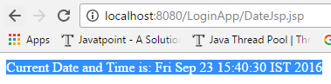

Struts

Hibernate

Web Services

JUnit

